How to compose and send an ICS-213 General Message Form using VARA FM Winlink
Author: Jim Frazier, KC5RUO
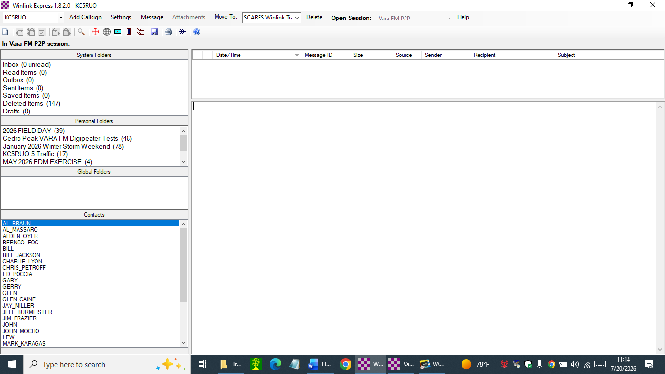
Open up Winlink Express
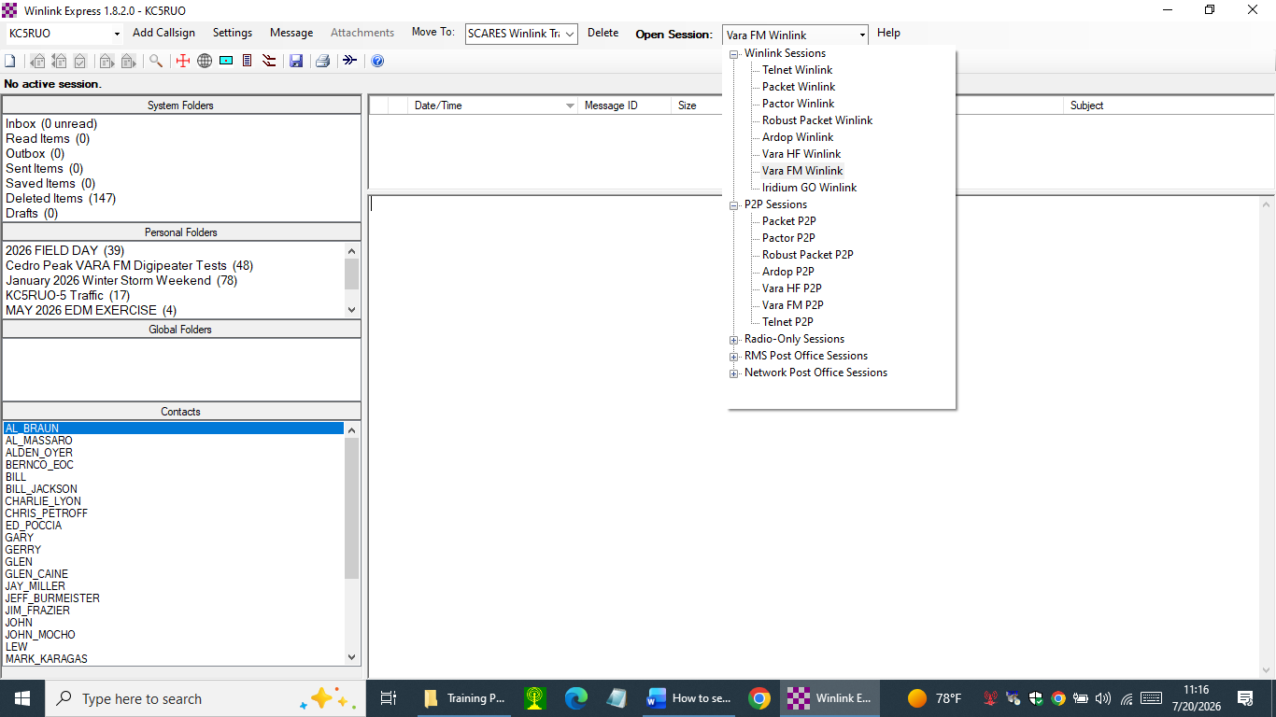
Select VARA FM Winlink

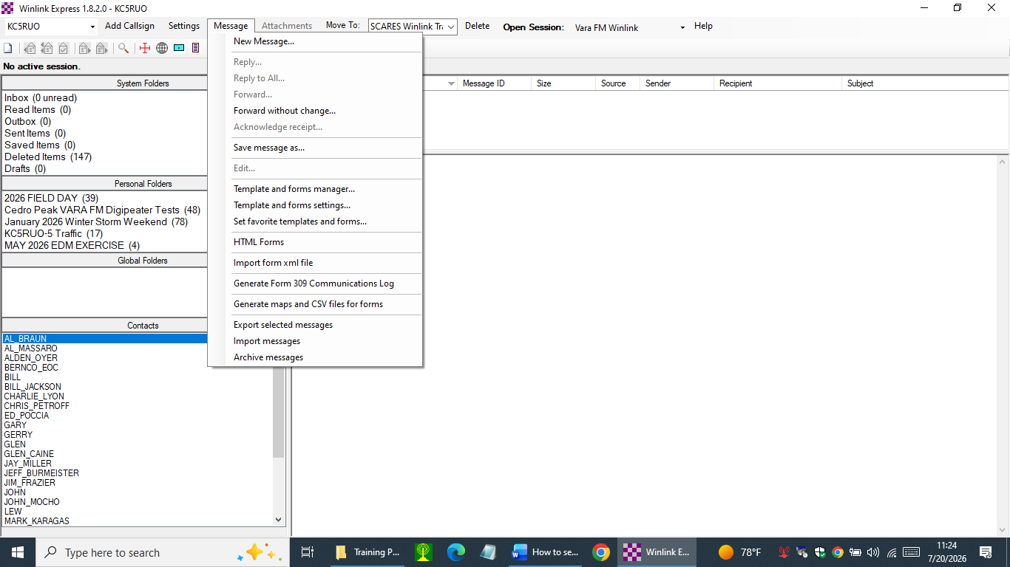
Select New Message

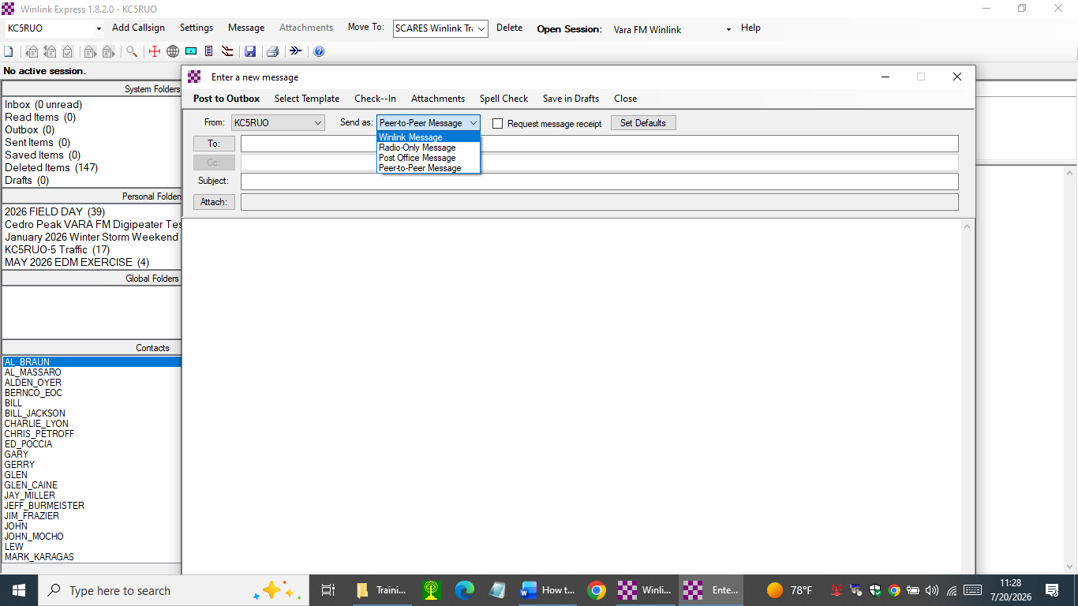
Select Winlink Message

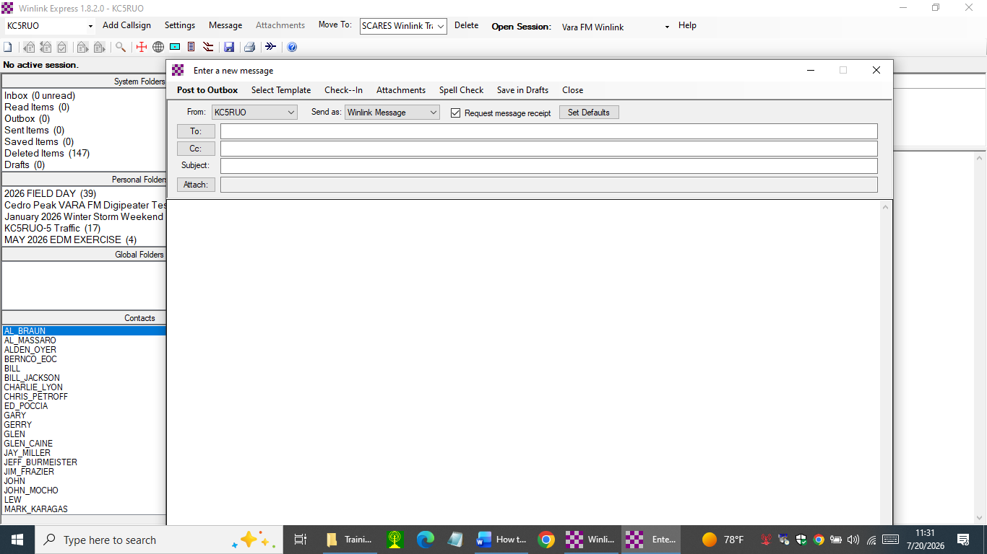
Click the Request message receipt
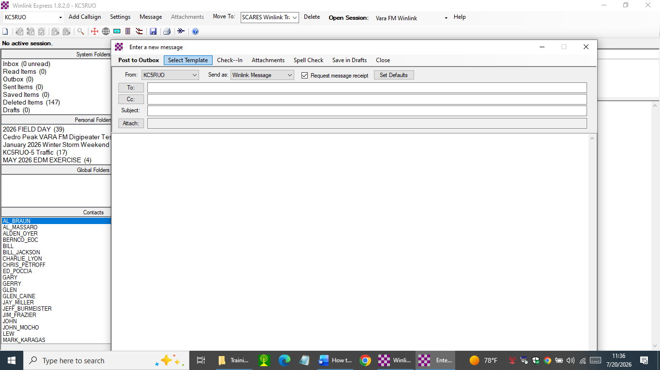
Select Template

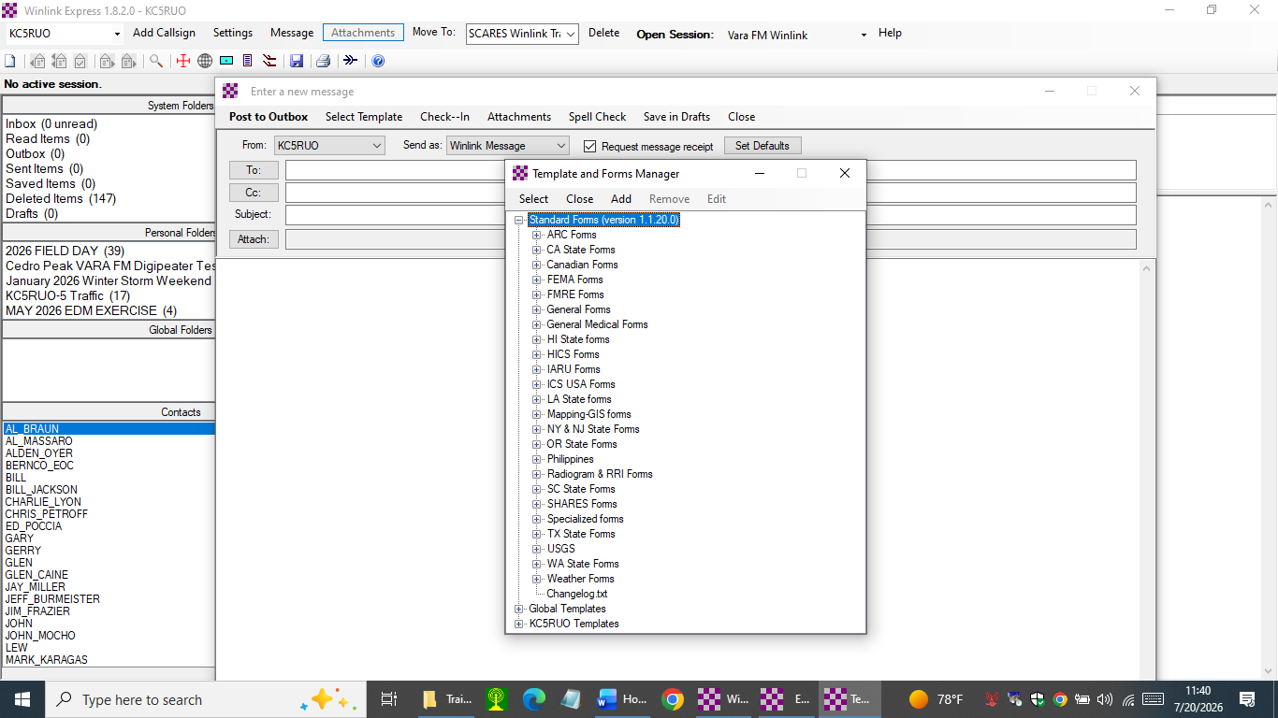
Select drop-down ICS USA Forms under Standard Forms

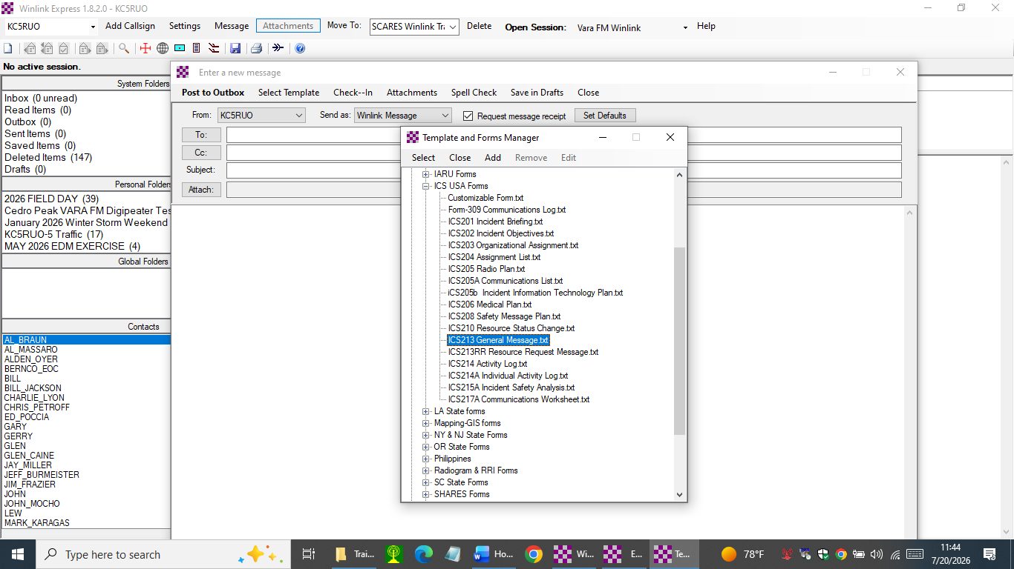
Select ICS213 General Message

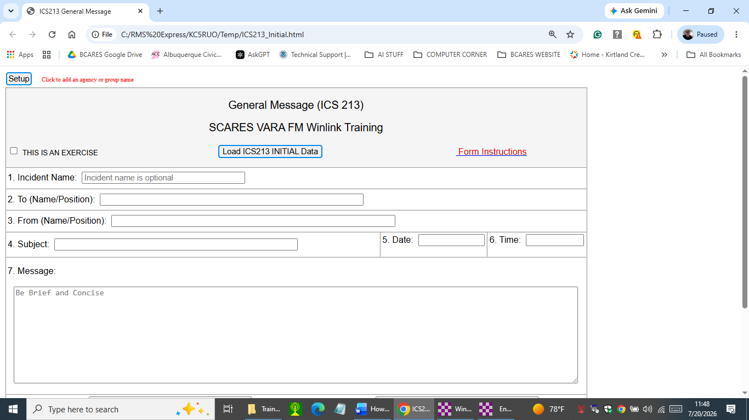
The ICS 213 opens up in your Browser

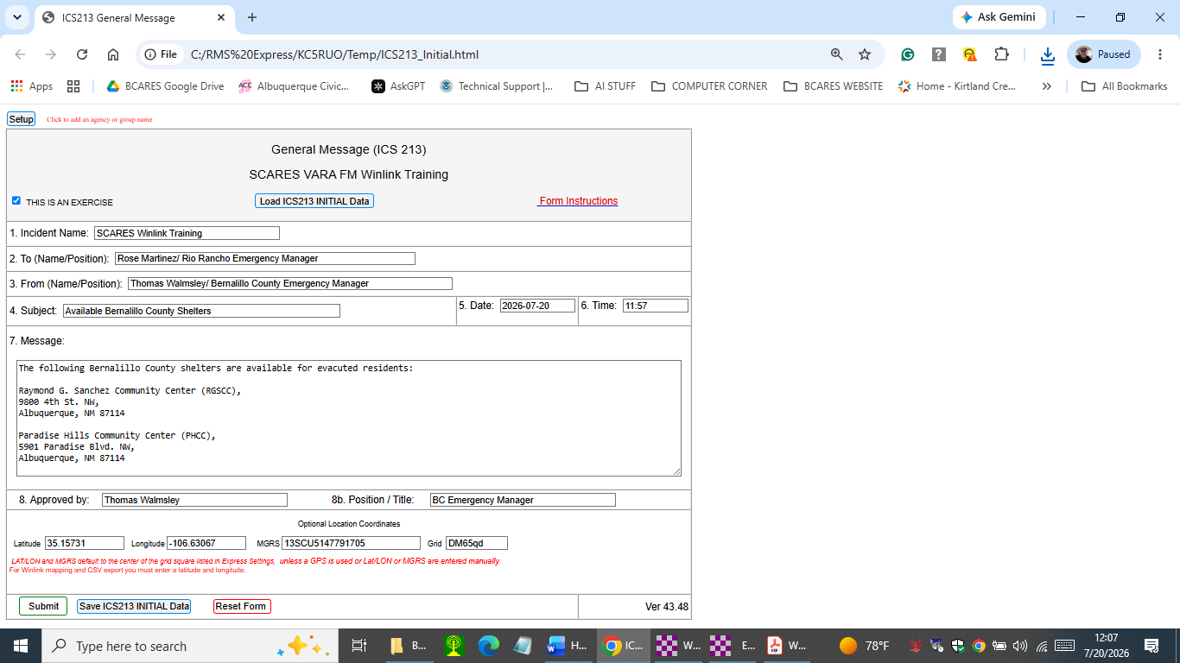
This is the coordinates for the sending station. In this case it is the Bernalillo County EOC.
The Date and Time fill in automatically when you click into the box
Note, the position is more important than the name.
The completed ICS-213

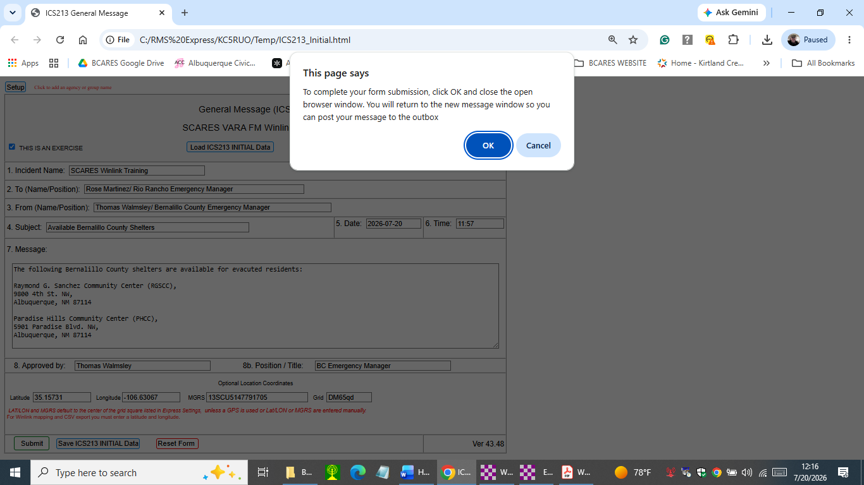
Select Submit and then click on OK

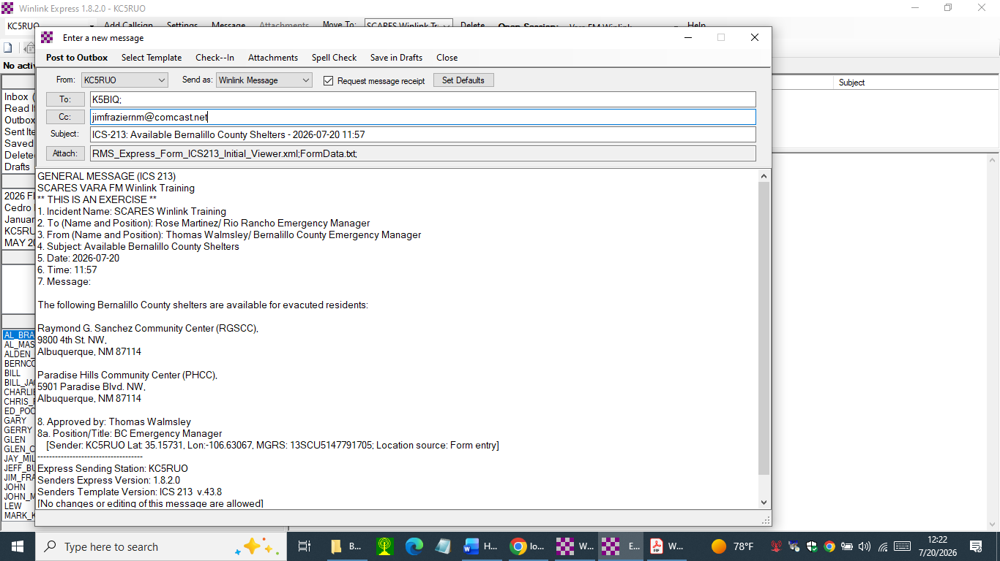
Review the content of this PENDING MESSAGE and then Post to Outbox
Insert the VARA FM Winlink radio operator’s call sign you are addressing the ICS-213 to.
In this example I included my commercial email address to verify the message went out.

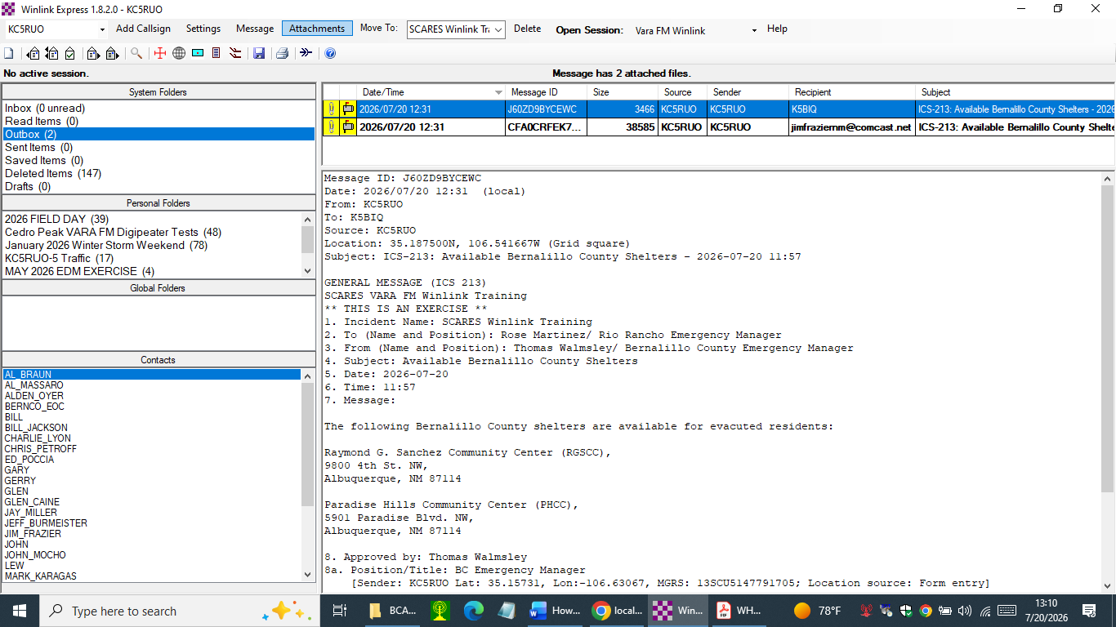
Note, there are now 2 messages in the Outbox. One addressed to K5BIQ and the other to a commercial email address.

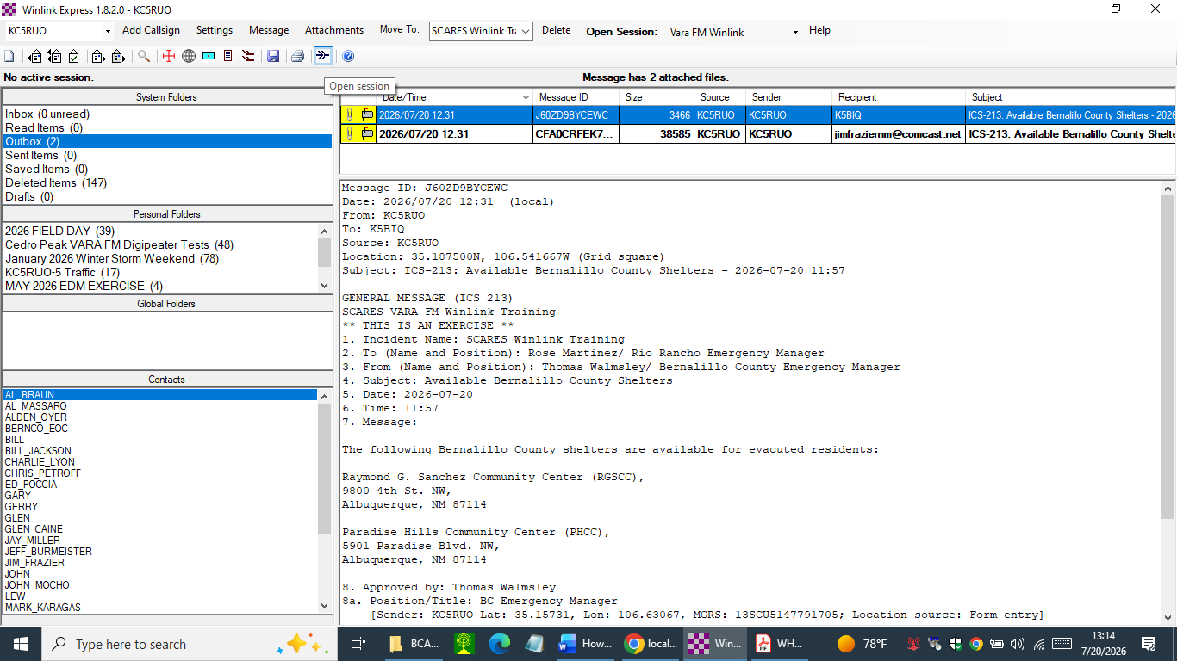
Now OPEN the Vara FM Winlink session. You can do that by double clicking on Open Session or select the “AMTRAK” icon.

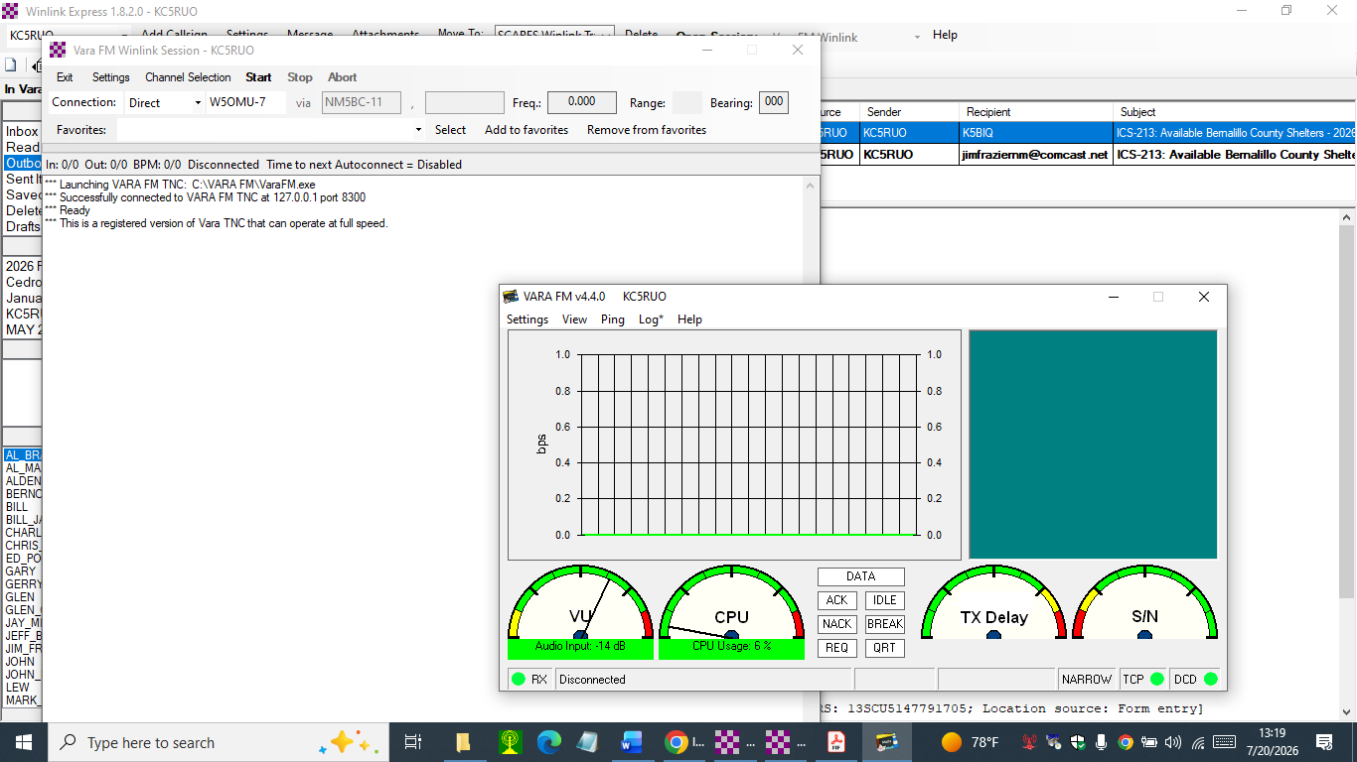
Notice the Winlink Express Vara FM Winlink Session is indicating “Ready”. That means the Winlink Express application is successfully communicating to the VARA FM Terminal Node Controller application via internal IP address 127.0.0.1 and Transmission Control Protocol (TCP) port 8300.

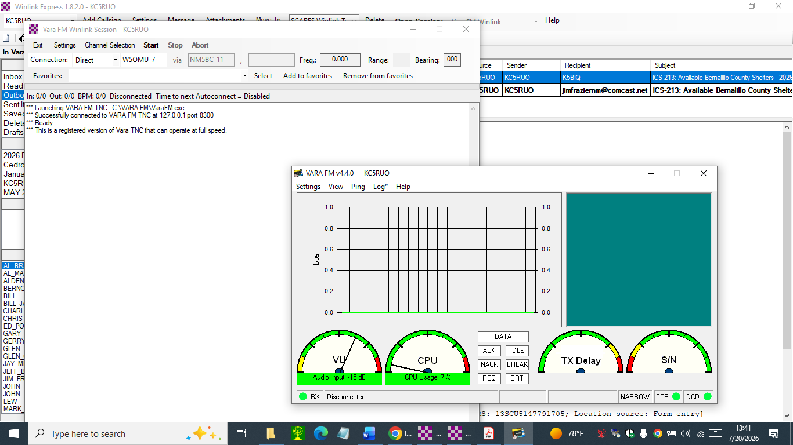
Also note that we are using a registered version of Vara TNC that enables us to use the higher Vara FM data rates and not limited to 1188 bps.

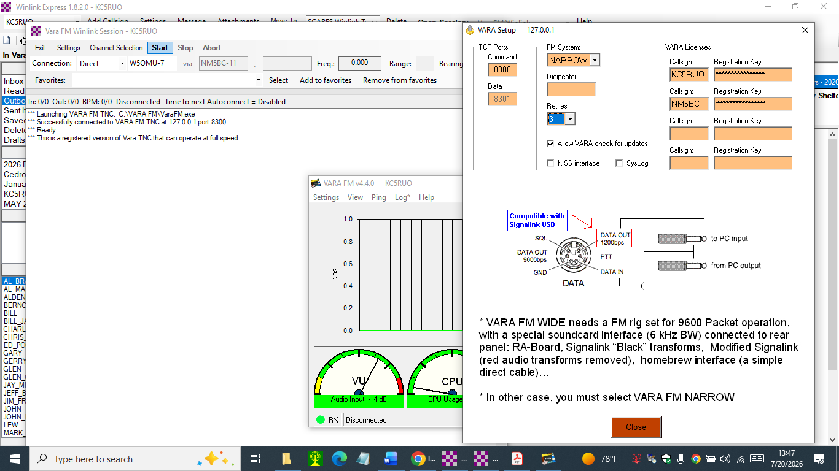
If you go to the VARA TNC Settings/Startup you will see we are using a licensed version of VARA TNC.
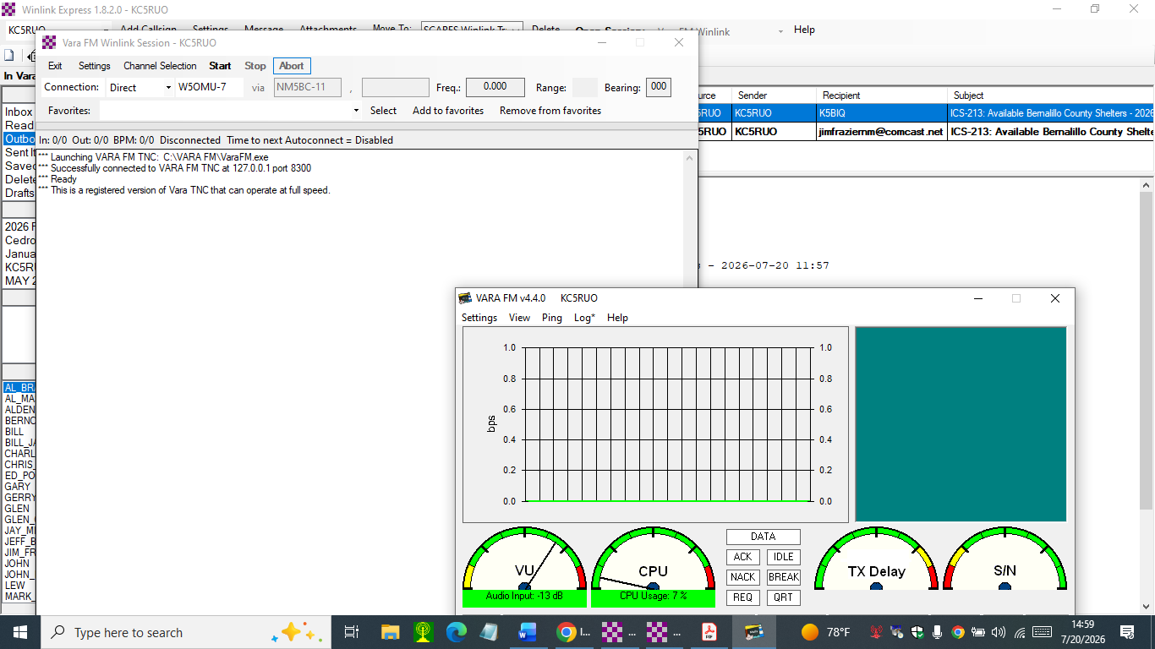
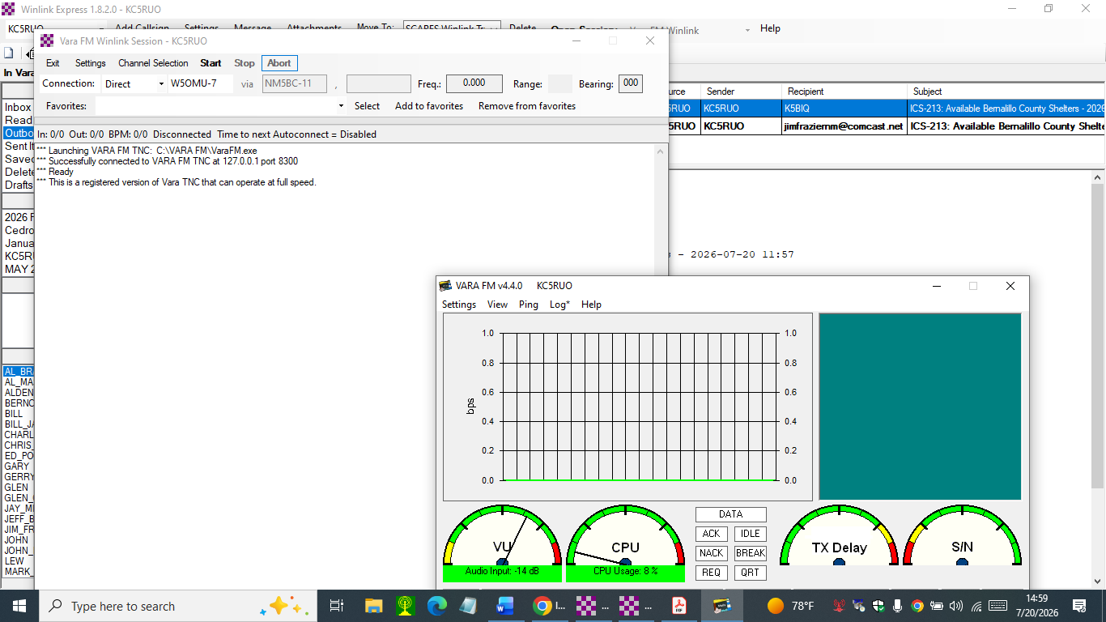
These two messages will be sent DIRECT to VARA FM Winlink Radio Message Server (RMS) Gateway, to W5OMU-7 on 433.025 MHz. But first, we’ll PING W5OMU-7 to verify we have a good connection.

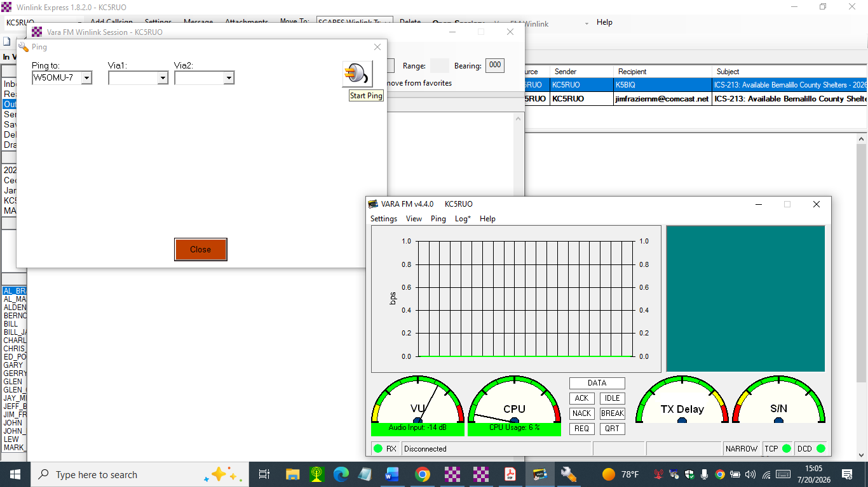
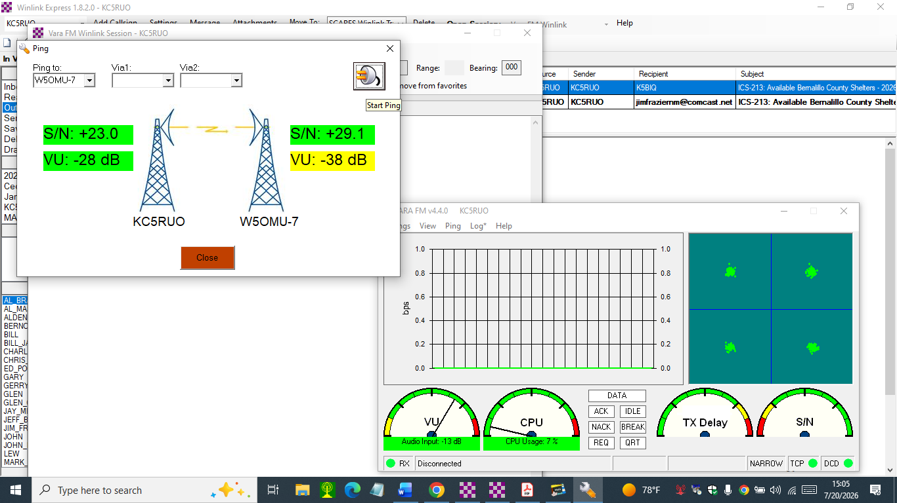
We don’t have an ALL GREEN status because the audio input level at W5OMU-7 is low.
But we’ll send the messages anyway.

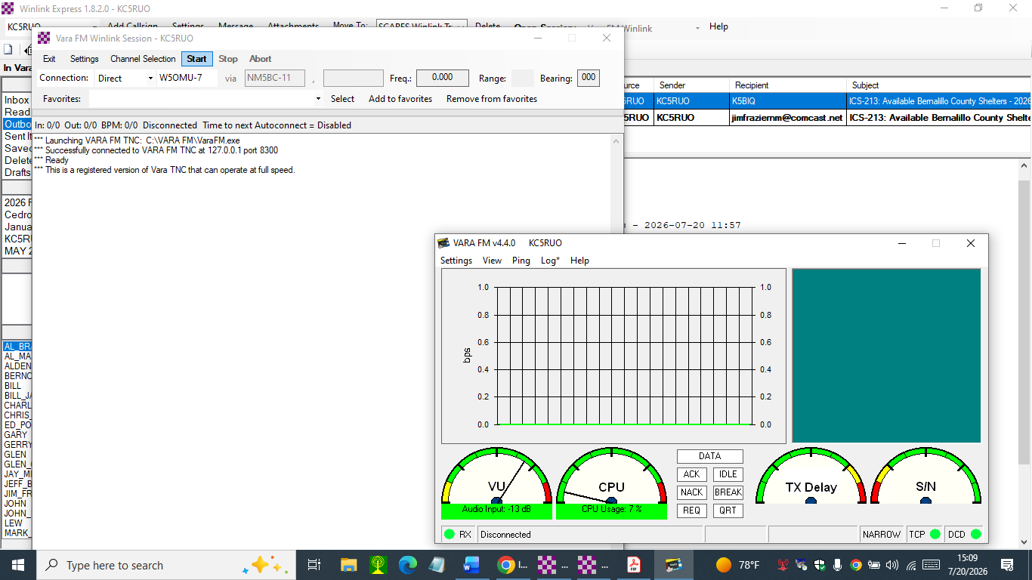
Select Start to send the messages.

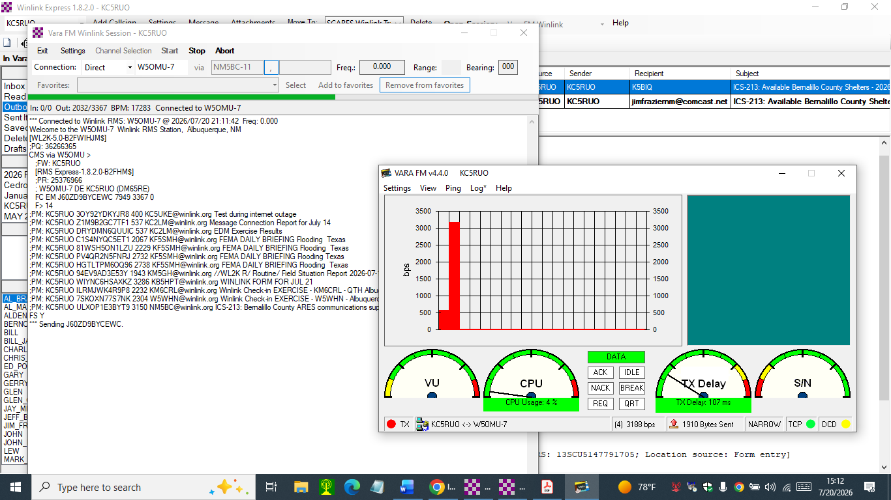
The Red column indicates the station is transmitting a message and the data rate.

The Green DATA window indicates message data is being passed successfully.

The transmit data rate is also shown here.

This is the message transmission progress bar.
Screen Shot #1 during the message transmission and reception. Note, there were many messages in the queue waiting to be sent to KC5RUO.

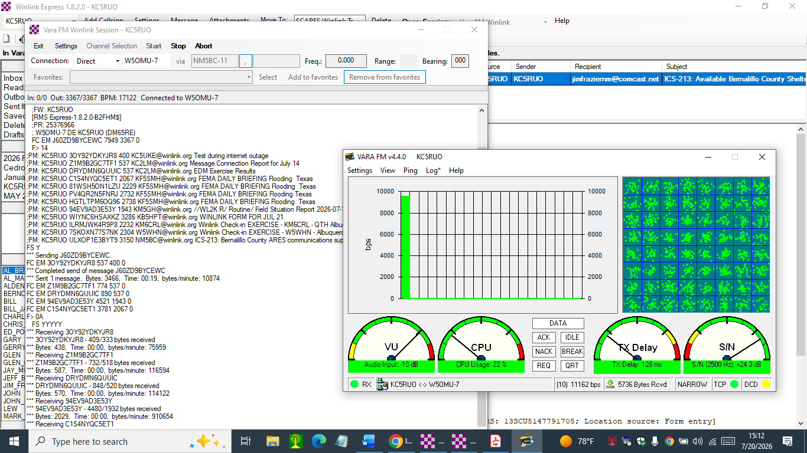
This window shows the signal constellation. At the moment of this screen shot data is being transferred using a high order modulation/demodulation scheme, 64 Quadrature Amplitude Modulation or 64 QAM.
The Green column indicates the station is receiving message traffic at the indicated data rate.
Screen Shot #2 during the message transmission and reception. This KC5RUO VARA FM station is configured as a VARA FM Narrow station but is still capable of receiving message traffic at 11,162 bps.

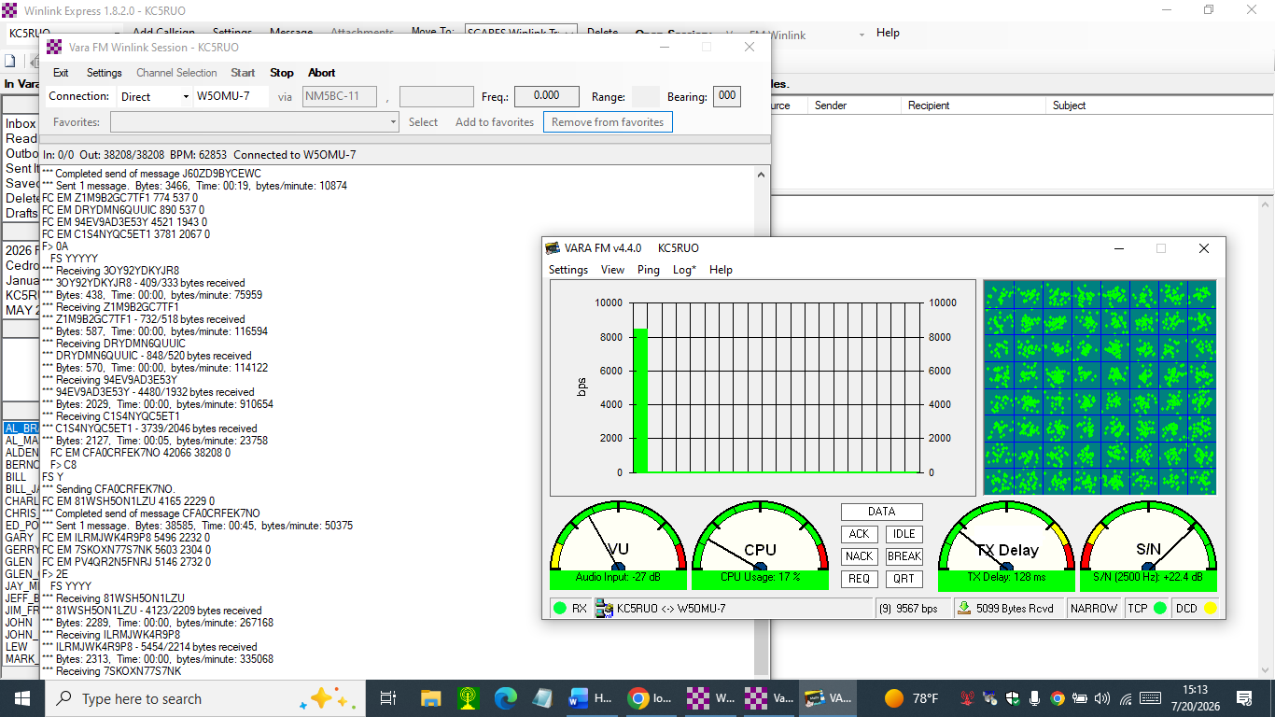
TX Delay indicates the delay time from when a packet of data is received and when this station responds with an acknowledgement.
This is the received signal-to-noise ratio measured over a noise bandwidth of 2500 Hz.
Screen Shot #3 during the message transmission and reception.

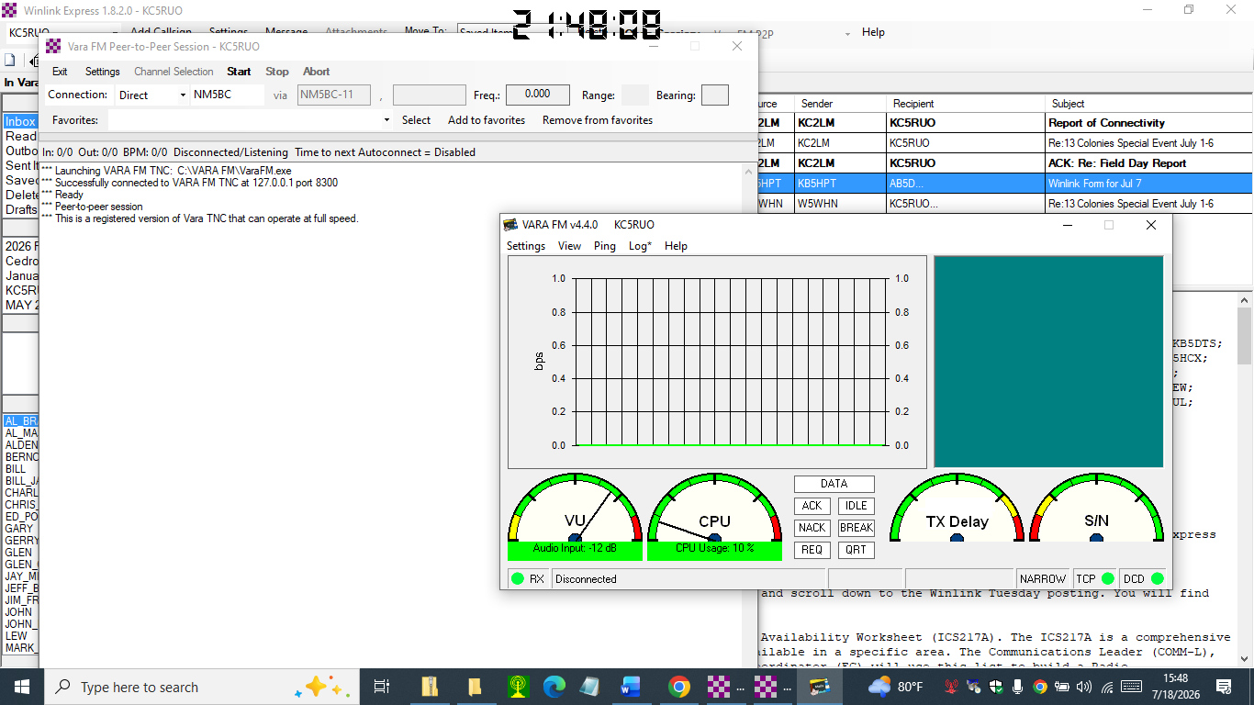

DCD = Data Carrier Detect
It detects the presence of a received audio tone(s)
TCP connection between the Winlink Express and TNC is operational

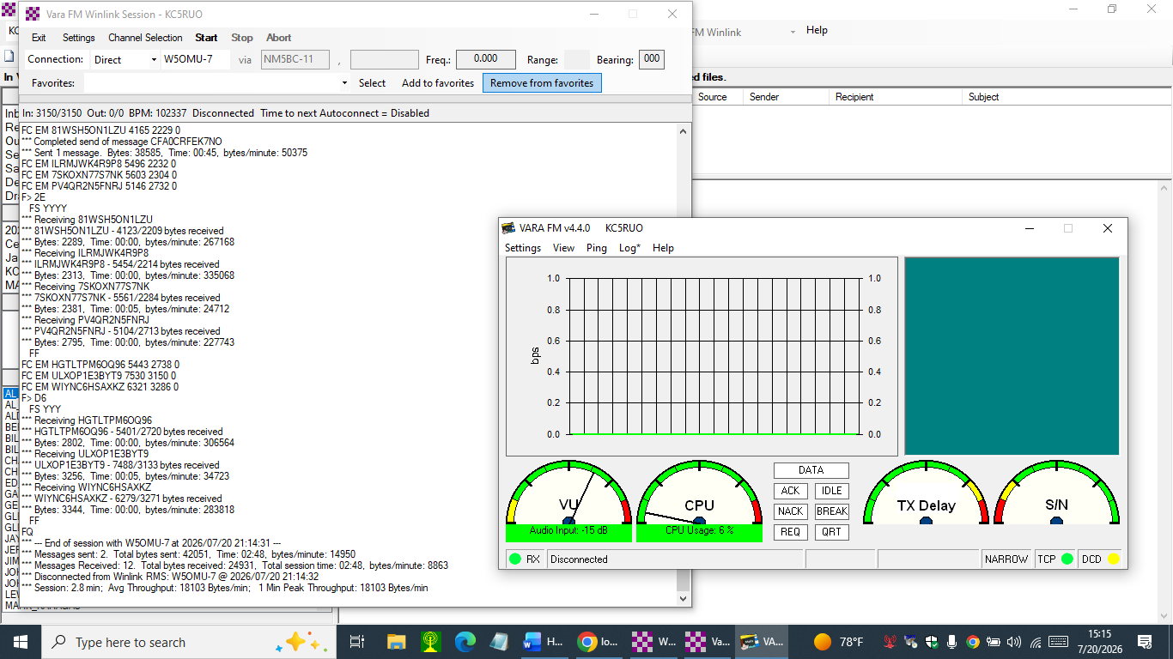
Screen Shot #4 at the completion of the message transmission and reception. Two messages were successfully transmitted and 12 messages received.

The two messages we transmitted are annotated in the Sent Items box.

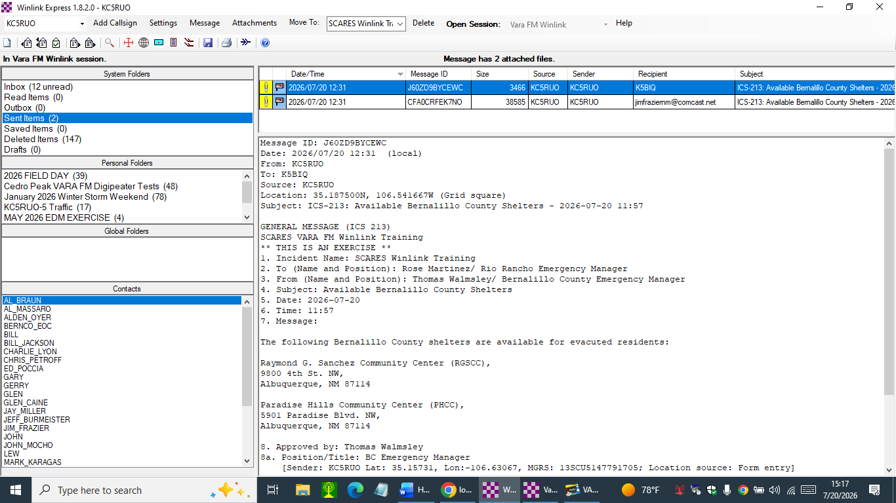
These are the 12 messages received in the Inbox.
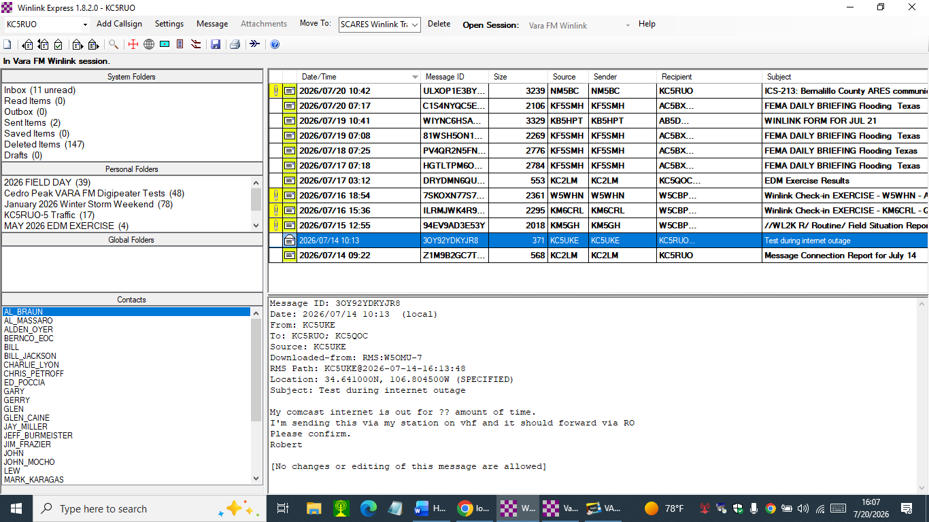

How to respond to an ICS-213 General Message Form using VARA FM Winlink
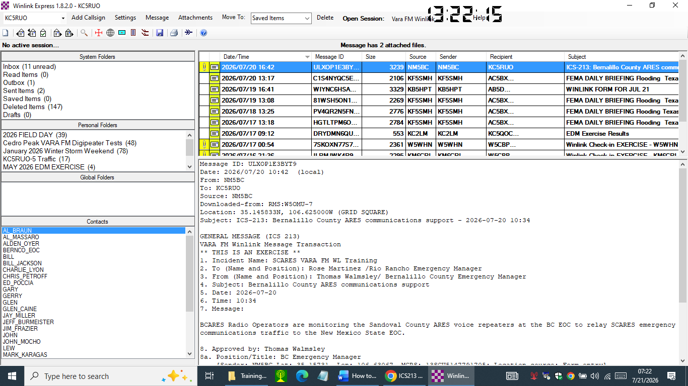
Open this received ICS-213
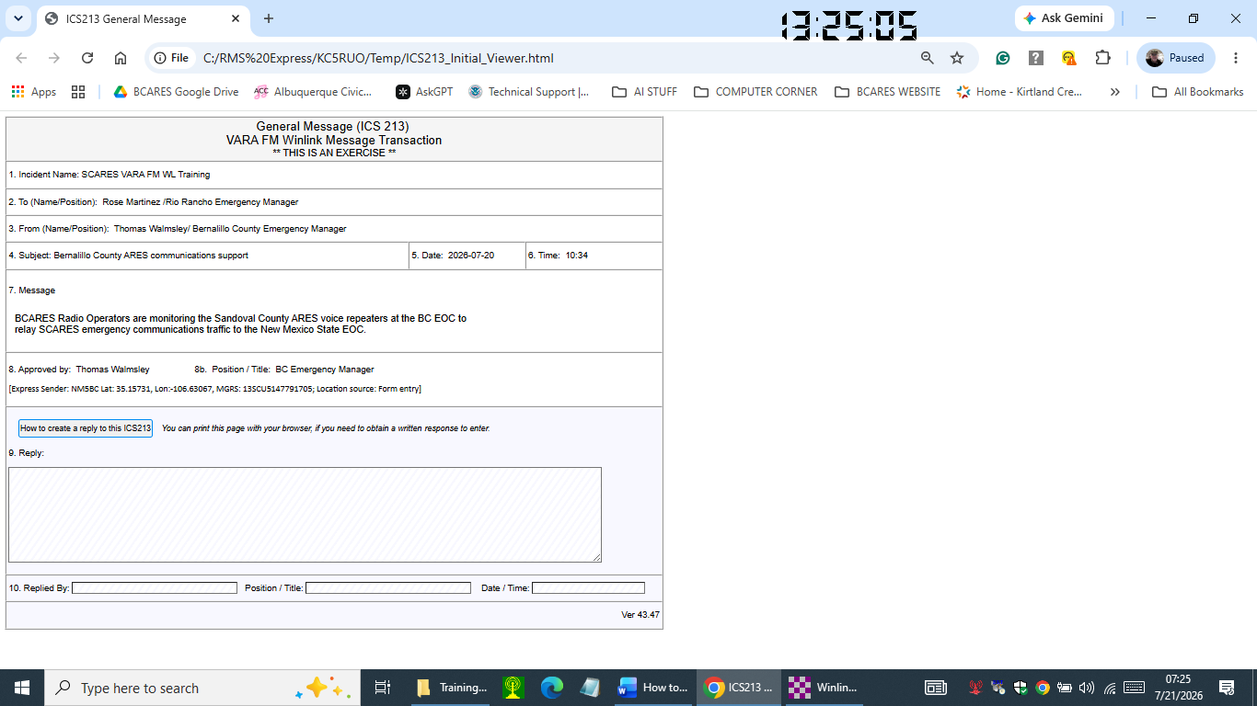
This is the ICS-213 that opens up in your browser that we want to respond to.
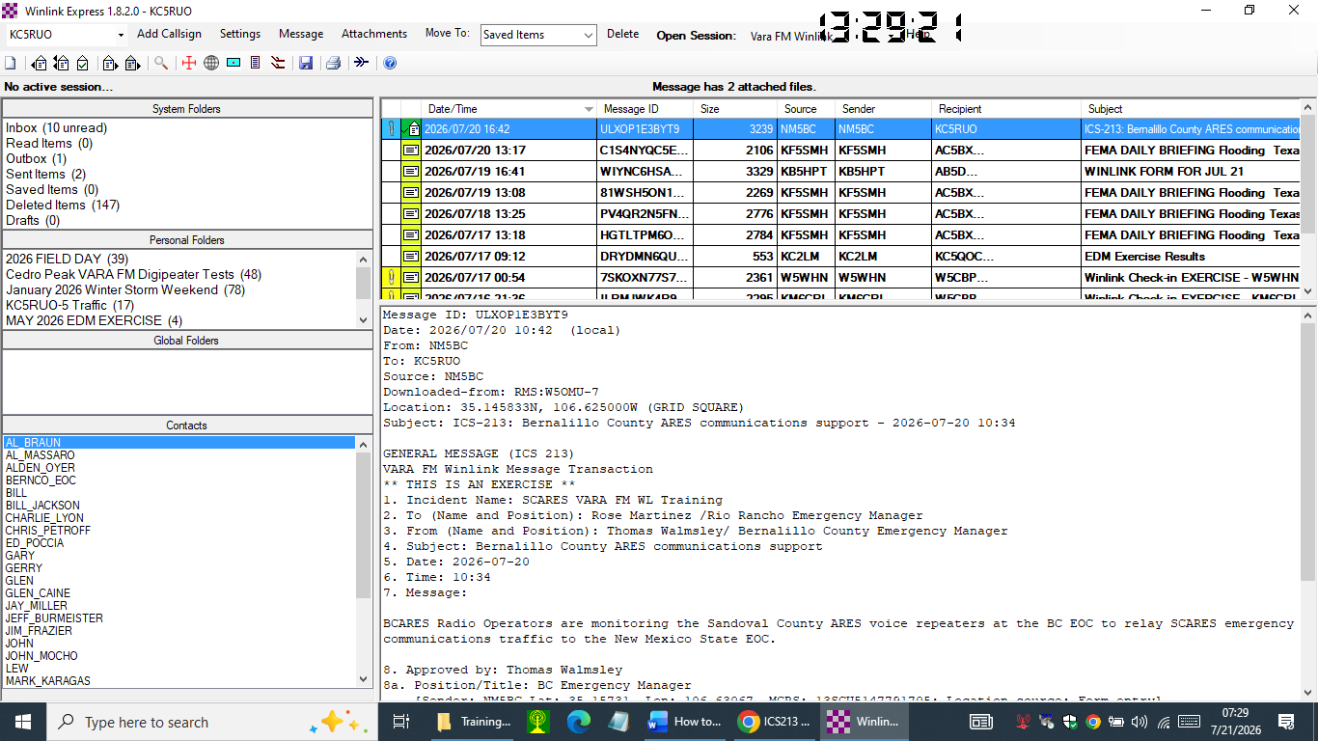
To reply, double click on this message in the Inbox
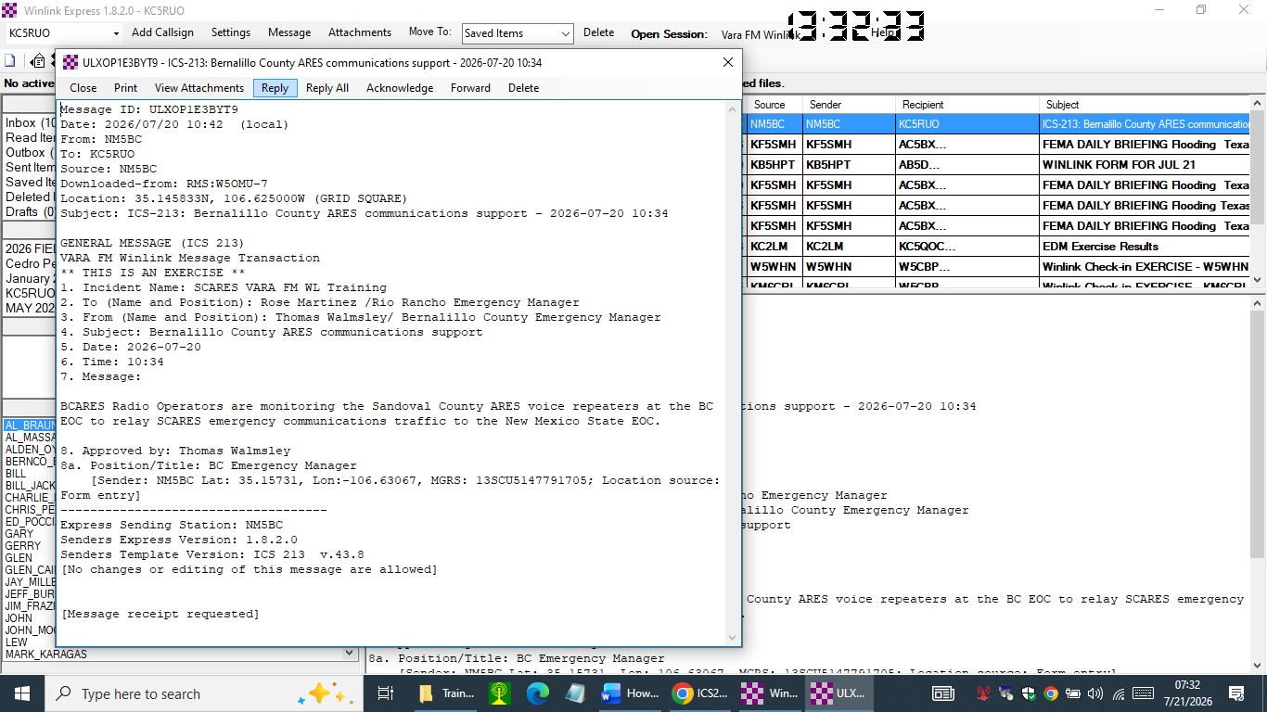
Select Reply

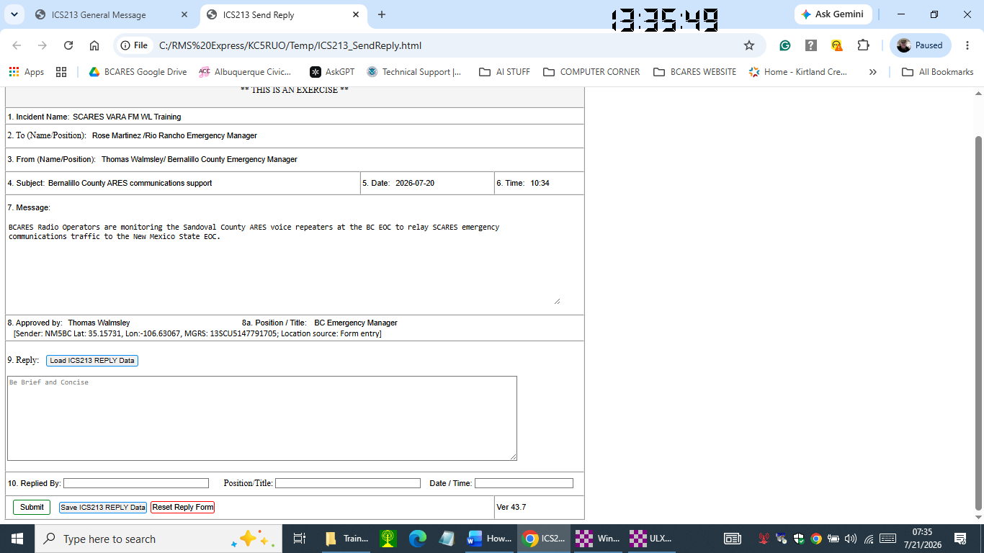
Note, the Item 9. Reply window is now available for text entry.
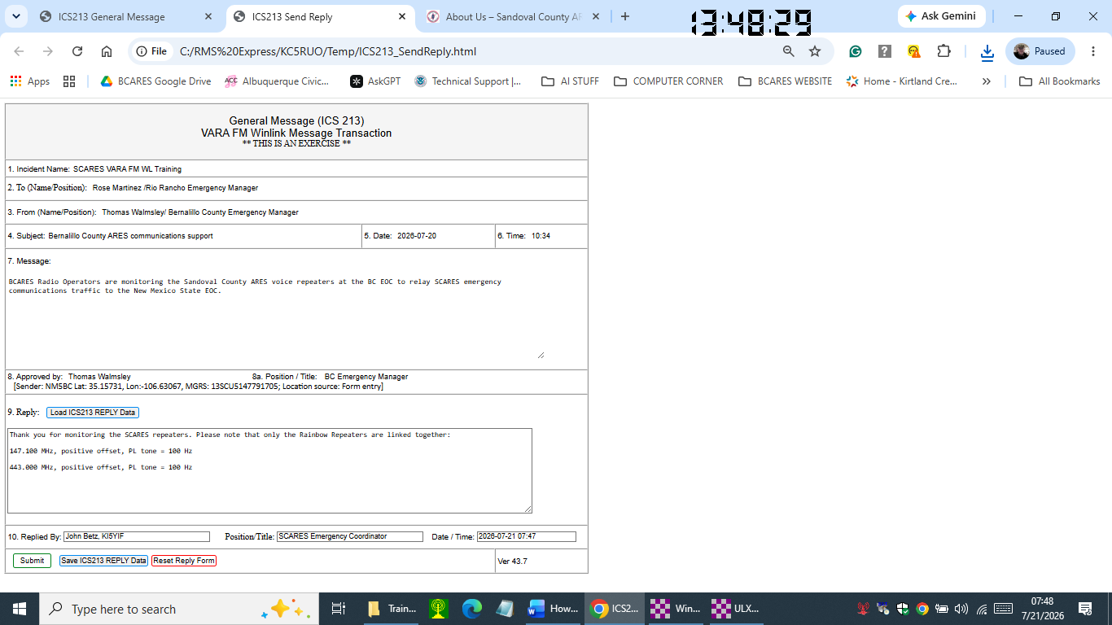
Reply entries

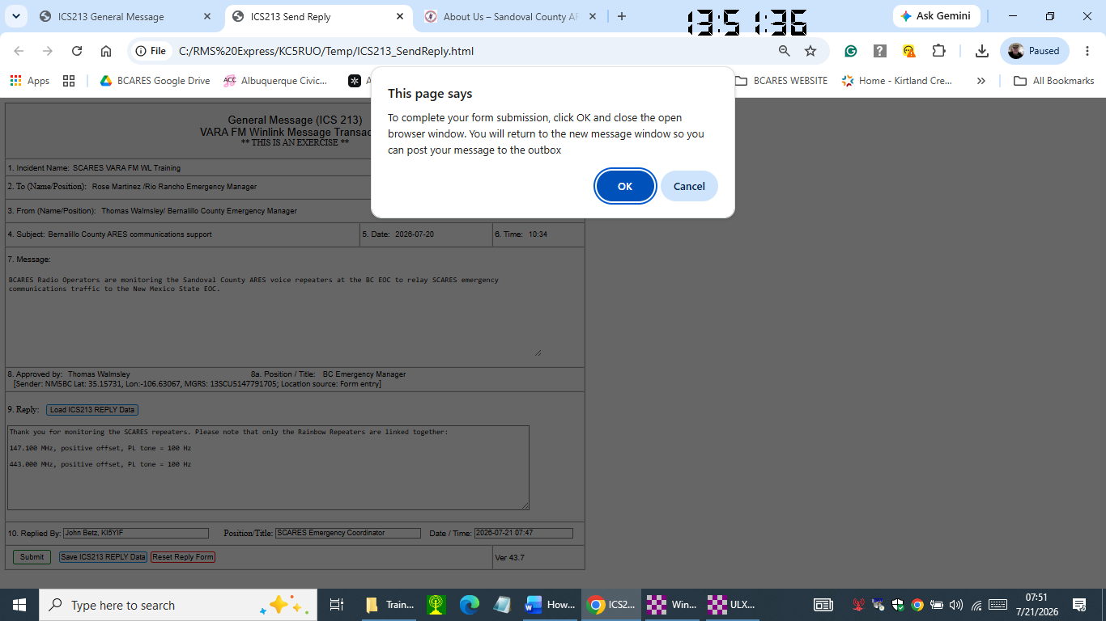
Select Submit and then OK
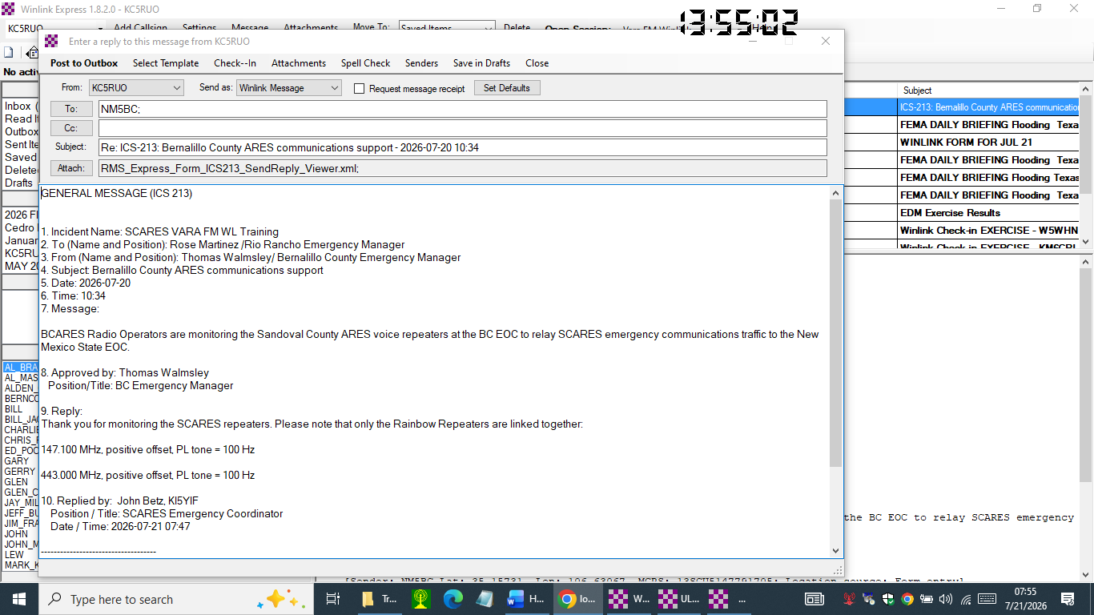
Review the Reply entry in this pending message.
Verify the Send as: window still annotates “Winlink Message”
And that it is addressed to the intended Winlink station call sign.
And then Post to Outbox

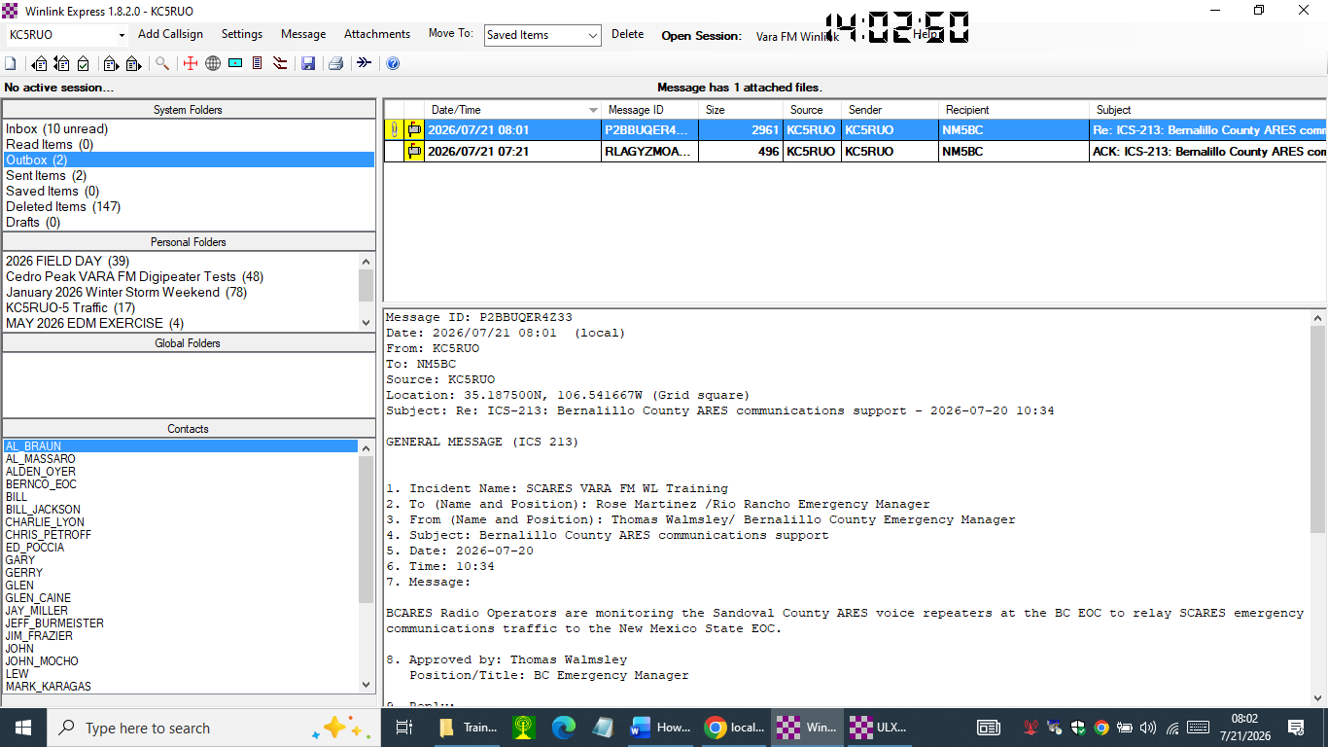
Note, the top message in the Outbox is the ICS-213 Reply.
The second message is the automatic response acknowledging the receipt of the original message.

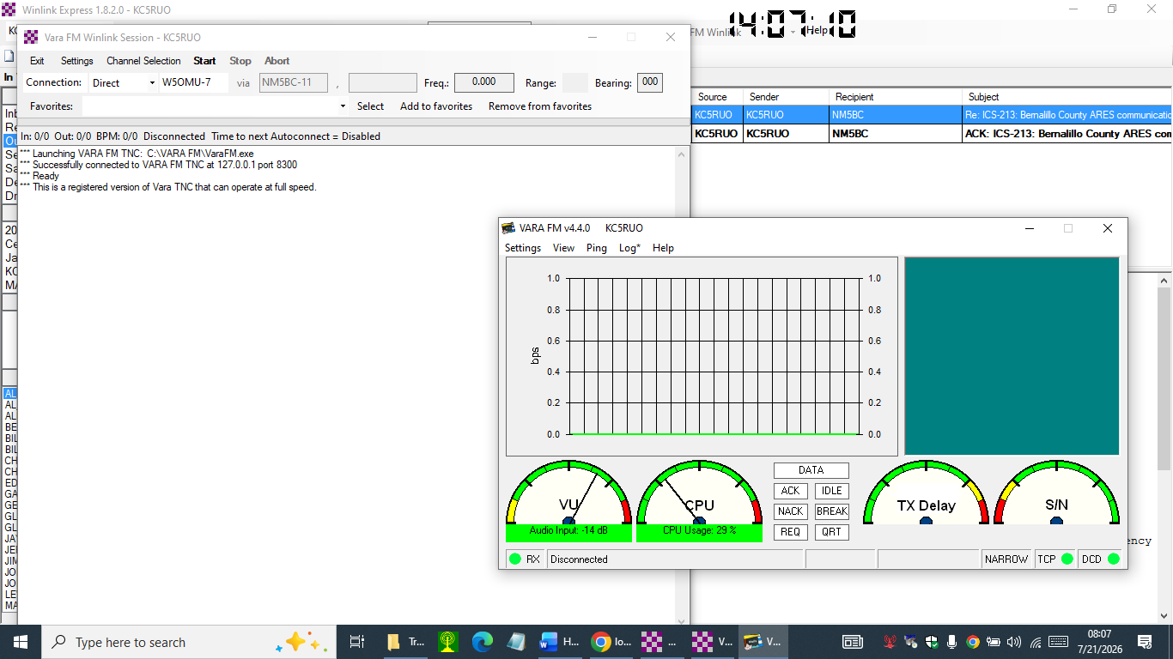
If the Vara FM Winlink Session was not open, open it again as shown here.

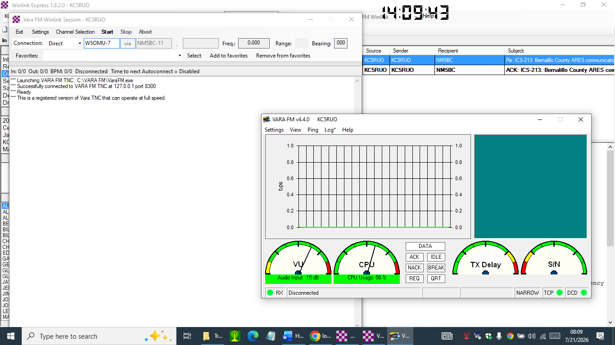
Verify you are sending the message to the intended RMS Gateway, in this case it is W5OMU-7, and then select Start.

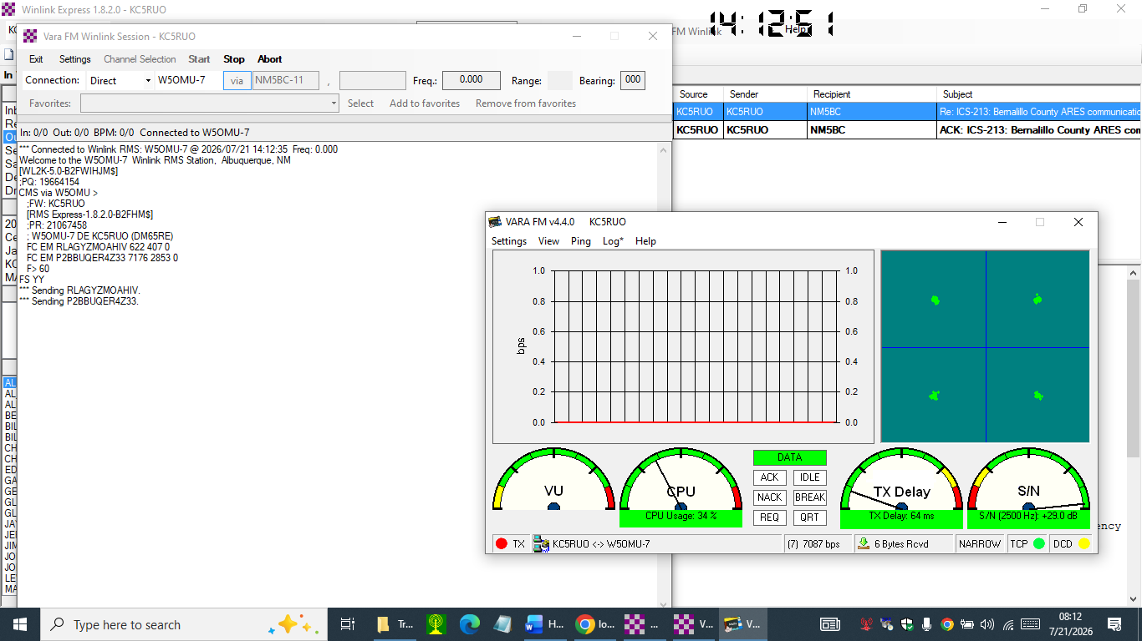

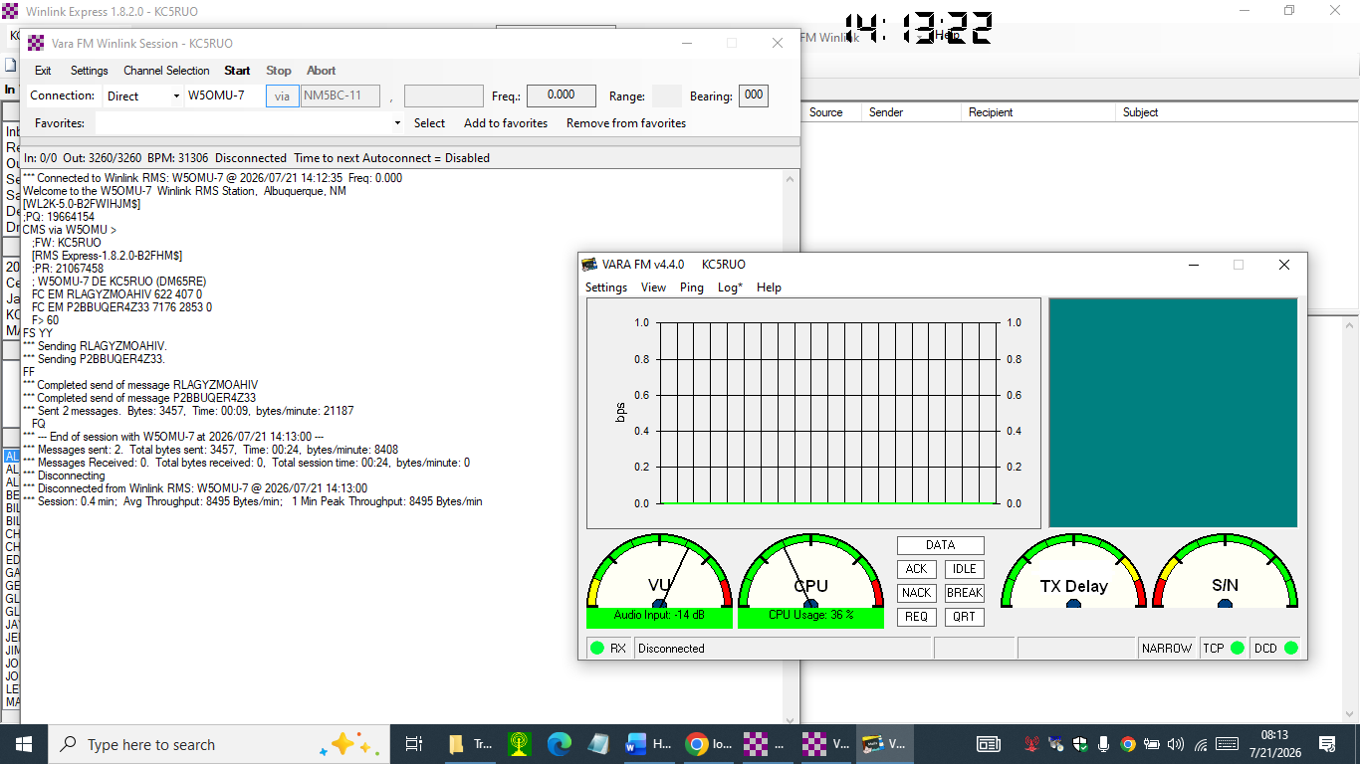

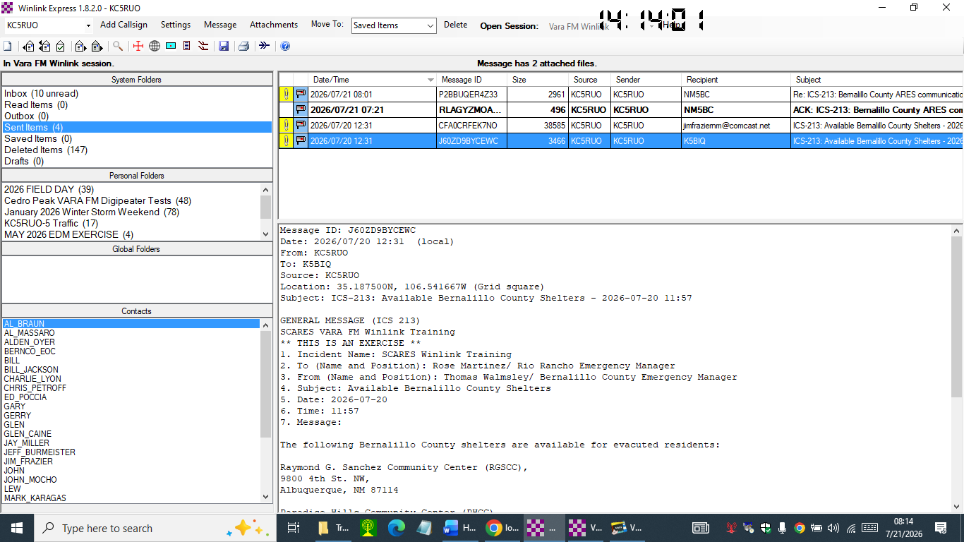
From the Sent Items listing you can see that both messages were sent.

VARA FM Winlink Communications us a VARA FM Digipeater
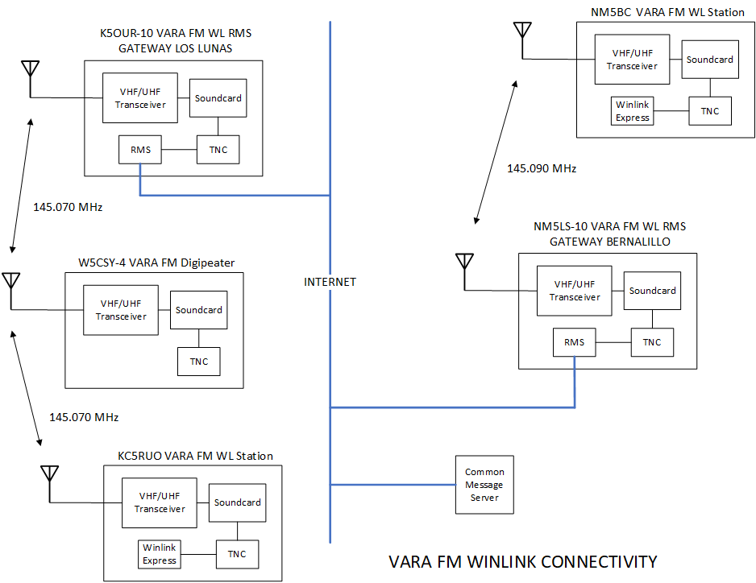

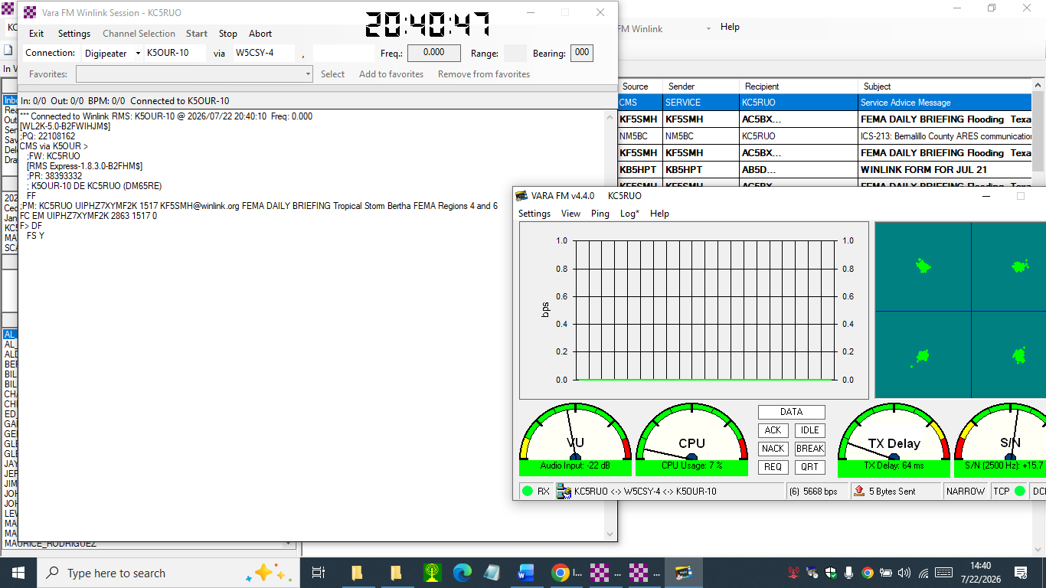
Configure the Vara FM Winlink Session window for Digipeater Operation.
W5CSY-4 is the Sandia Crest VARA FM Digipeater operating on 145.070 MHz
K5OUR-10 is the VARA FM Winlink RMS Gateway in Los Lunas, NM.

