How to Calibrate your VARA FM Winlink Station
Author: Jim Frazier, KC5RUO
Definition of a calibrated VARA FM Station: A calibrated VARA FM station is first, a station that has set its Transmit Audio Drive Level so that its receive Signal-to-Noise (S/N) ratio at the distant end station is adequate to recover the message data. And second, a calibrated VARA FM station is also a station that has set its Receive Audio Drive Level so that it can recover the distant end station's message data.
- The receive audio level must be set so as to not overdrive the Analog-to-digital converter (ADC) which is the soundcard chip.
  - I will be showing you how to set the optimum receive audio level
- The transmit audio must be set so as to not overdrive or underdrive the audio signal that modulates the carrier.
  - An overdriven transmit audio signal will spread the FM carrier bandwidth out beyond the detection bandwidth of the receiver and thus reduces the receive signal level needed to successfully demodulate and decode the digital data.
  - The VARA FM terminal node controller AUTO TUNE operation assists you in setting the transmit audio drive level and I will be showing you how that is done.

- First time calibration of station.
  - Reference the soundcard manufacture instructions for setting the Microsoft (MS) sound Audio Input (Recording) and Audio Output (Speakers) levels.
  - If none provided, I recommend the following initial conditions:
    - With the radio in OPEN SQUELCH mode adjust the MS Audio Input Level until the VARA Terminal Node Controller (TNC) Audio Input VU meter shows the needle in the GREEN between the 1 and 2 o’clock position.
    - Next, I recommend setting the Transmit Audio Output Level setting in the following manner:
      - Set the initial TNC audio drive level in the Settings/SoundCard to -6 dB.
      - Set the MS Audio Output Level to 50.
      - Then run AUTO TUNE and follow its instructions. AUTO TUNE will automatically set the TNC Drive Level. But you be instructed to adjust the TX Dial on your SignaLink USB soundcard, or adjust the MS audio output level.
    - After you achieve an AUTO TUNE APPROVED status, PING the distant end station to see if it responds with an ALL GREEN response.
      - If no ALL GREEN response, follow the Interpretation of VARA FM PING Response document and make the indicated adjustments.
- Checking the calibration of an already calibrated station
  - PING the distant-end station.
  - If PING response is not ALL GREEN, follow the Interpretation of VARA FM PING Response document and make the indicated adjustments.
- I always recommend AUTO TUNING and PINGing to the Sandia Crest Digipeater, W5CSY-4. It is the MASTER STATION for the Albuquerque area. If every station is calibrated against W5CSY-4, every station should then be calibrated with each other whether you intend to use the digipeater for communications or not.
- Calibrating your station when using a VARA FM digipeater for data communications with another station.
  - PING the digipeater
  - If the response is not ALL GREEN, reference Interpretation of VARA FM PING Response document and make the indicated adjustments.
  - After achieving an ALL GREEN status with the digipeater, PING the distant end station. Hopefully, it will respond with an ALL GREEN status as well. If it doesn’t, there isn’t anything you can do about it because you are sending and receiving traffic with the digipeater which is in between your station and the distant end station.
  - NEVER AUTO TUNE the distant end station when using a digipeater. It doesn’t make sense to AUTO TUNE the distant end station because you are communicating with the digipeater, not the distant end station.

- Demonstrate calibrating my station as though it is being done for the first time.
- But FIRST PING W5CSY-4 to show the station is already calibrated.
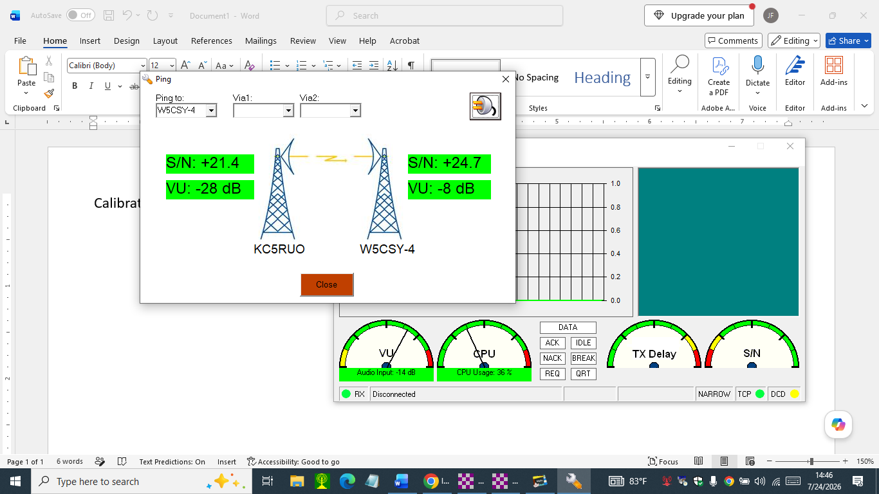
- These results were achieved with the Yaesu FTM-300D transceiver following configuration:
  - MS Audio Output Level set to 100
  - MS Audio Input Level set to 100
  - TNC Drive Level set to -3 dB
  - SignaLink TX Dial = 12 o’clock
  - SignaLink RX Dial = 9 o’clock
- Procedure as though station was never calibrated to W5CSY-4
  - MS Audio Output Level set to 100 – because Tigertronics said so
  - MS Audio Input Level set to 100 – because Tigertronics said so
  - Set the TNC Drive Level to -6 dB
  - With the radio in OPEN SQUELCH Set RX Dial to achieve an audio input level VU meter reading between 1 and 2 o’clock
  - Show the Receive audio level control path

Set to 100 per Tigertronics instructions
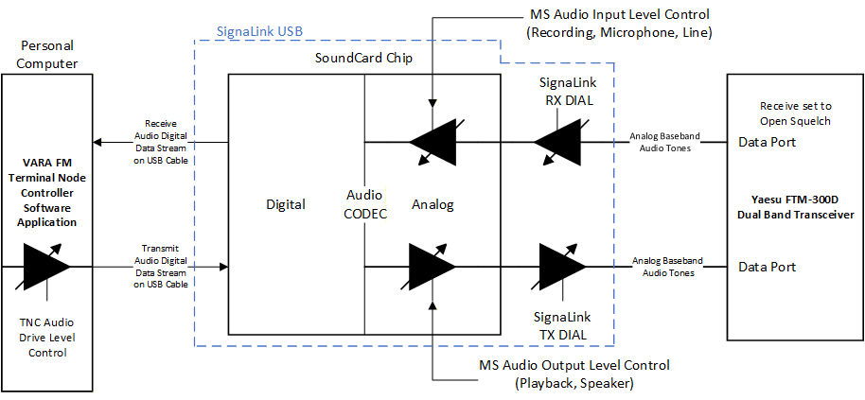
Initially set to -6dB
Set to 100 per Tigertronics instructions
  - Show the TX audio level control path
  - SET THE TNC DRIVE LEVEL TO -6 dB
  - MS Audio Output Level is already set to 100
  - So the only adjustment of the TX audio level is with the SignaLink TX Dial
    - Set TX DIAL = 9 o’clock
  - Now conduct an AUTO TUNE
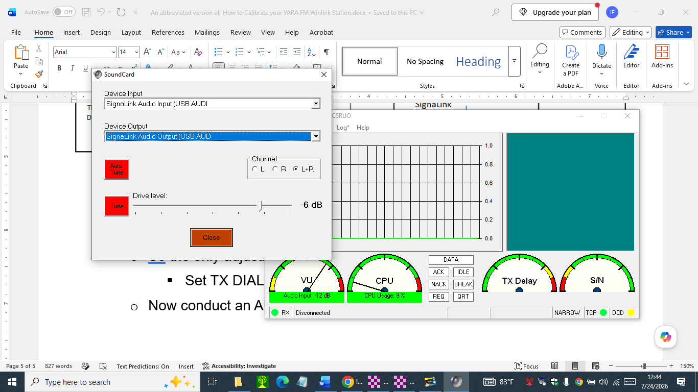
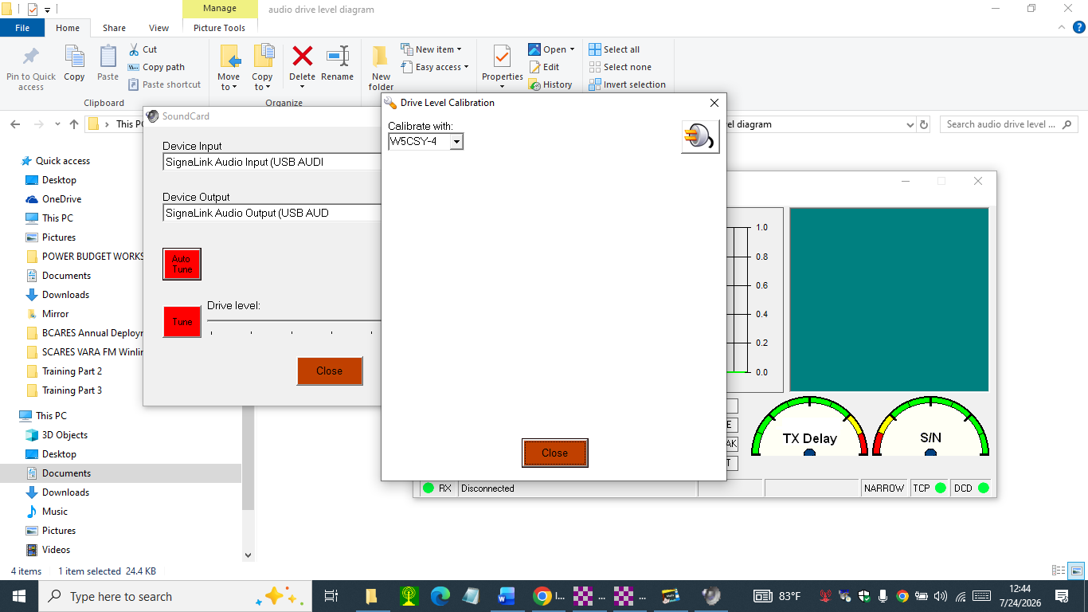
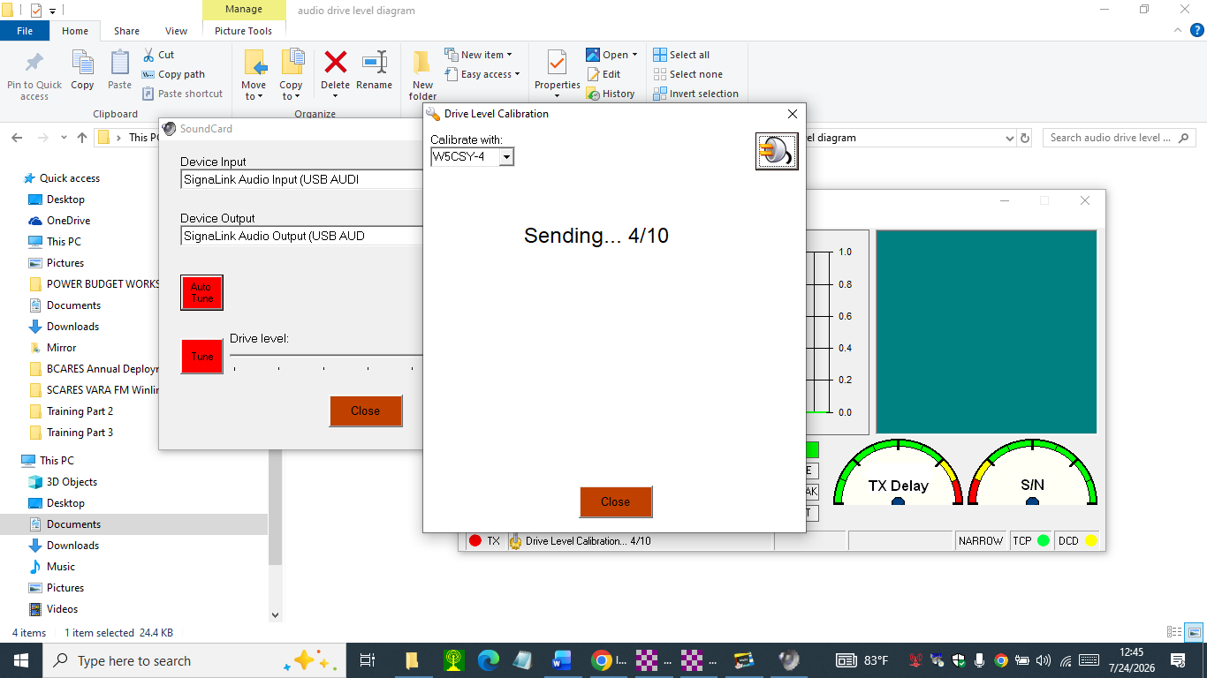
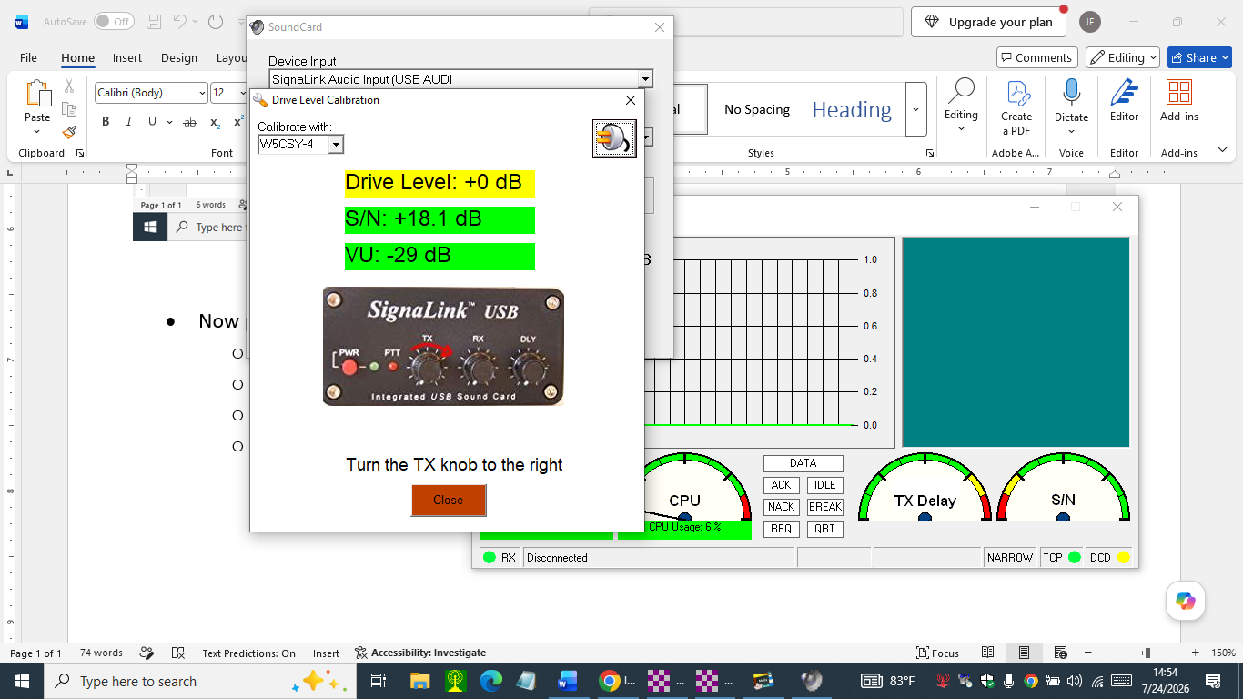
- Increase the TX DIAL setting to 10:30 o’clock
- AUTO TUNE again.
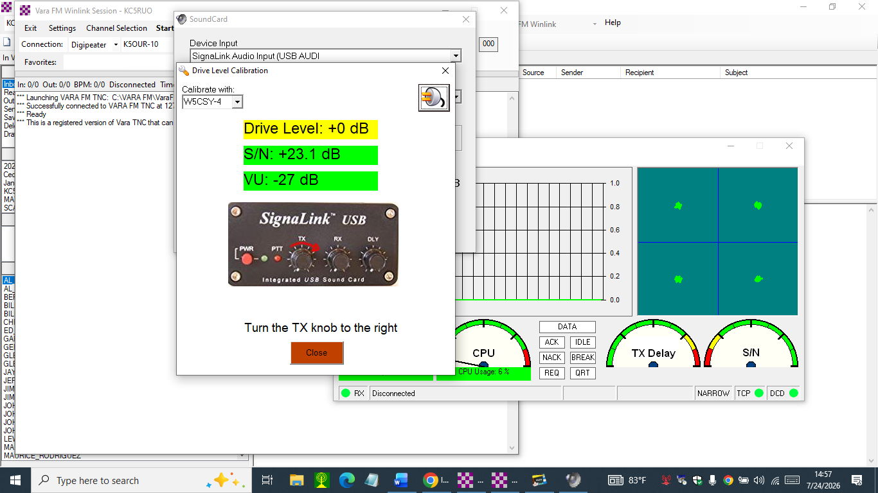
- Increase the TX Dial setting to 12 o’clock and AUTO TUNE again

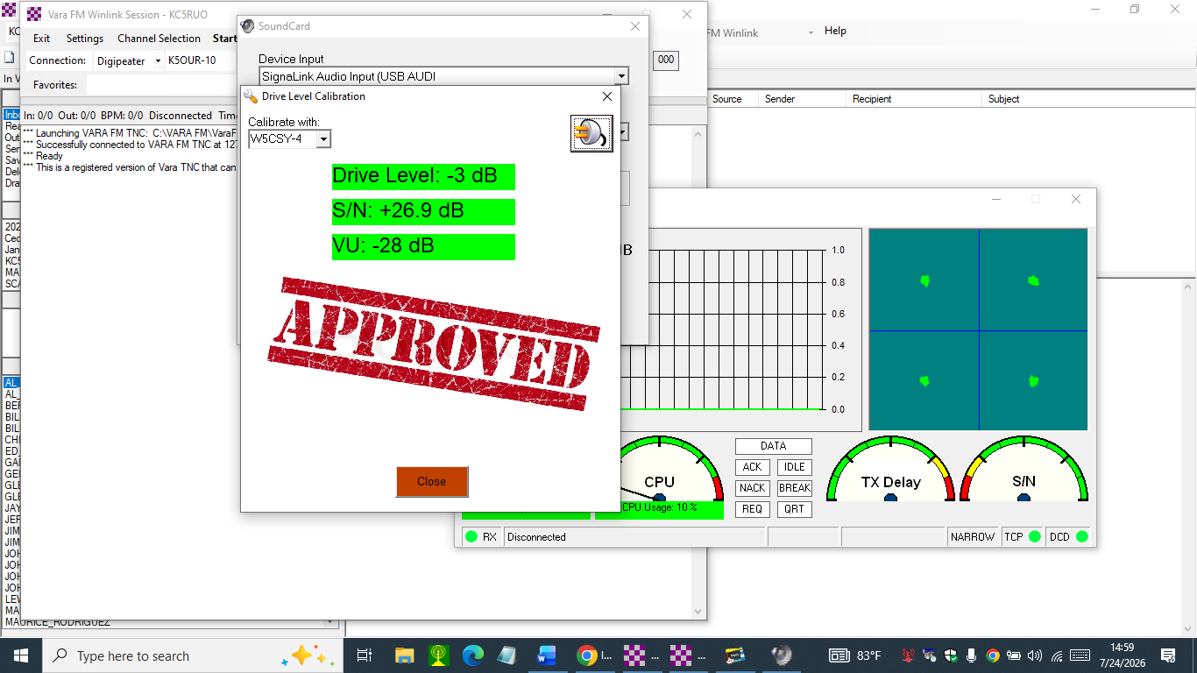
- The TX DIAL was set 12 o’clock and the AUTO TUNE function set the TNC Drive level to -3 dB, where it was before doing this exercise.
- Now PING W5CSY-4
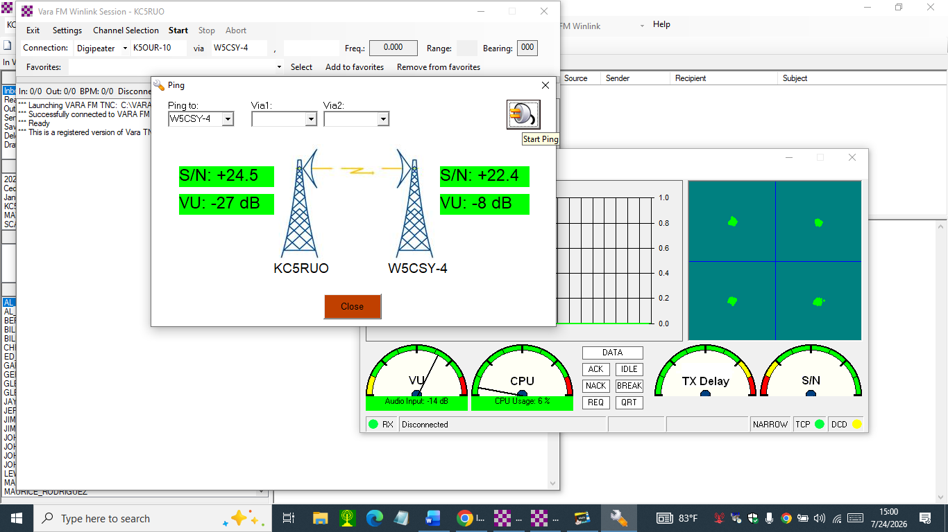
- ALL GREEN – the VARA FM Station is now calibrated.

