A simple EMP primer for EMCOMM Stations
By Brian Britt, KG5WED, with information from Richard St. John, Ph.D.

ElectroMagnetic Pulse or EMP, is a damaging RF & Electrical phenomenon associated with high-altitude Nuclear detonations or natural sources. It can (and has) damaged and destroyed communications and power equipment in the past, and with current equipment relying on even more vulnerable circuitry, has the potential to create widespread disasters.

As it is generally occurring above the atmosphere, it is also known as High-altitude ElectroMagnetic Pulse, or HEMP. EMP/HEMP comes with 3 main components (E1, E2, & E3); in a High Altitude Nuclear Detonation, all three components are present from the same event. From natural solar sources, only the E3 type of EMP occurs.

The particulars of each type of EMP are:

- E1 -- Nuclear only source. Very long range if High Altitude burst, nanosecond to millisecond time duration, and has two simultaneous components:

- Conducted (induced high voltage via wiring or an antenna) - Suppressed by line disconnection/suppression of short time transient voltages on lines and antennas.
- Radiated (high amplitude RF energy spike in the 100's MHz. ranges, short wavelength allows coupling to circuit board level conductors) - Suppressed by complete RF (Faraday) shielding of circuits.

- E2 -- Nuclear or Natural (Lightning) source. Very long range if from a High Altitude Nuclear burst, but lower amplitude than other EMP components, a few hundred microseconds time duration. - Suppressed using standard lightning protection grounding and surge suppression techniques.

- E3 -- Nuclear or natural (Solar) source. Low Frequency. Solar Flares and Coronal Mass Ejections (CME's) inducing Geomagnetic Storms (example: Carrington Event) are the most likely of all EMP types to affect EMCOMM and other radio stations. Can be widespread, range dependent on location and strength, time duration can last for several minutes due to disruption and resultant motion of the earth's geomagnetic field. - suppressed by transient + surge voltage suppression on long lines that the Geo-Magnetic Field (GMF) can induce voltages in, mostly mains power. However, while damaging voltage effects are limited to a few minutes, the disturbances to the GMF will affect ionospheric radio communications for a much longer time scale. Also, the difference between a nuclear and solar E3 disturbance can be very different in duration, as Solar CME's are in a stream, versus an instantaneous nuclear explosion. E3 has two time-shifted components:

- E3a initial (Blast) energy disruption of Geomagnetic Field, with subsequent motion of the field as it stabilizes causing induced voltages in long conductors. Electrical coupling generally lasts several seconds, but ionospheric disturbances can persist for extended periods of time

- E3b secondary (Heave) disruption, as atmosphere heated to plasma states and generates electric fields that also effect the GMF. This can cause damaging electrical long line coupling that lasts several minutes following the blast.

EMP in the past has caused telegraph lines to catch fire (the 1859 “Carrington Event”) and power outages over large areas (March 1989 Solar Flare) from E3 induced voltage on long electrical lines:https://www.space.com/12584-worst-solar-storms-sun-flares-history.html. In 1962 an above-atmosphere nuclear test, “Starfish Prime”, is an example of the damage that EMP (E1,E2, & E3) can cause: https://www.military.com/daily-news/2017/05/13/electromagnetic-pulse-attack-would-devastate-hawaii.html. The Soviet Union also did a similar test that damaged power stations and other equipment over a wide area: https://en.wikipedia.org/wiki/Soviet_Project_K_nuclear_tests. The Soviet test did much more damage than Starfish Prime, even though it was a smaller blast, because it was over major population areas, similar to an actual attack.

SUMMARY of effects & required protections:

- E1 - High Frequency and amplitude voltage induction to even stand alone circuit boards, may damage or even destroy circuits. Faraday shielding & surge voltage suppression required.
- E2 - Strong voltage spike similar to lightning strike to unprotected circuits. Good grounding and suppression protection needed.
- E3 - Induced voltages in long power lines or lengthy antenna assemblies could damage unprotected circuits. Does not induce damaging voltages in short conductors. Long-time duration could bypass some automatic protection circuits. Disconnection or long duration surge suppression on incoming mains power or long antenna cable assemblies needed. Faraday enclosures are not needed for solar-generated E3 EMP.

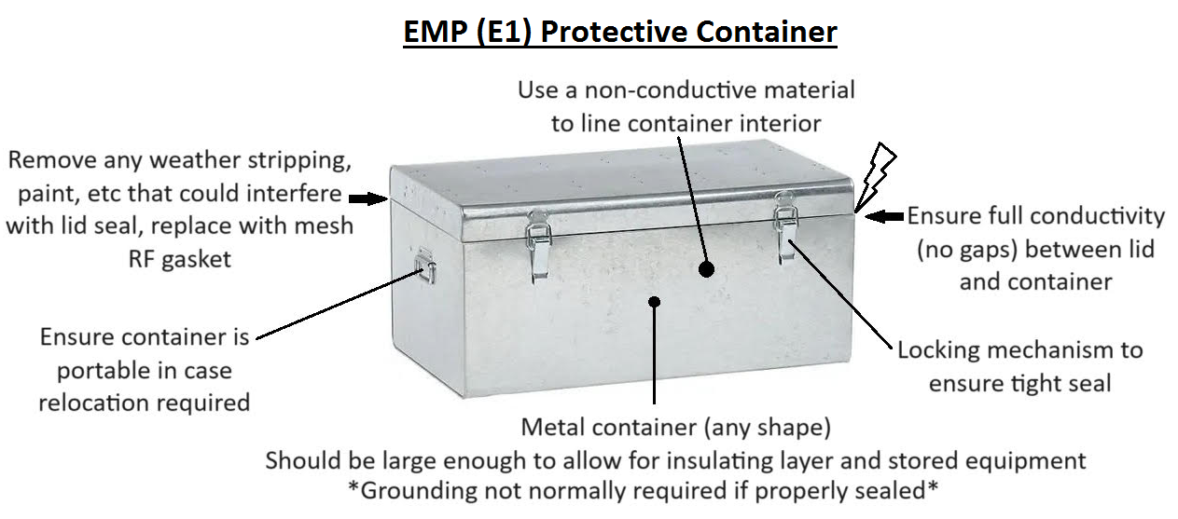

E1 EMP Protective Container requirements:

- Shielding equipment is not needed for E3 solar protection
- Solid/Continuous Metal construction. Even tiny gaps may allow microwave RF to penetrate. EMP Bags/Foil containers provide less protection than thicker metal containers (see link about material thicknesses, below).
- No gaps in contact surfaces-lids or doors must make continuous electrical contact around circumference. Lid preferably with an overlapping contact area. Use RF Gasket to enhance protection if needed.
- Pad interior with insulative material or container to keep electronics from contacting metal surfaces on interior of container.
- Sufficient space for electronic devices (including radios, communications accessories, phones, spare solar controller, computer/tablet)

Example: YouTube instruction for an EMP Can (Faraday protection from E1 Radiated EMP) https://www.youtube.com/watch?v=3rx7VjhfoFU

Calculations of material thicknesses required for E1 protection: https://www.cloudynights.com/topic/830478-faraday-shield-to-block-carrington-or-e1-emp-pulse/

E3 Protection for Amateur Radio Stations

E3 ElectroMagnetic Pulse, also known as Magneto HydroDynamic (MHD) EMP and also late-time EMP, is created during a high altitude thermo-nuclear burst or a high intensity Solar flare/Coronal Mass Emission (CME) striking the upper atmophere. Because this type of pulse disturbs the Earth's geomagnetic field on a large scale, the motion of the field and the extended length of time it takes to stabilize can induce high voltage spikes in lines for periods ranging from 1/10th of a second, to hundreds of seconds long, unlike the E1 & E2 variety which are extremely short (nanoseconds - milliseconds) in duration. Protection devices and methods for E3 are therefore required to guard for a much longer period than those effective for E1 & E2.

The primary threat of E3 EMP to Amateur Radio stations is from low frequency geomagnetic disturbances inducing current in long lines, such as power lines, and extended lengths of antenna wire and its associated cabling. The shorter length of Portable (H/T) and Mobile antennas, as well as any equipment boards or wiring, is too short to be susceptible to E3 induction, although E1 & E2 EMP can be an issue for these, if present. In general, the longer the line that E3 EMP contacts, the stronger the voltage induced will be.

Another factor to consider when evaluating equipment protections is the distance and strength of the EMP source:

- If the E3 EMP is from a high-altitude nuclear attack (and coupled with both E1 & E2 because of this), the strength and distance covered will be very high and widespread as well, so location will likely matter very little in reducing the threat of equipment damage.

- If the E3 EMP is from a solar flare/CME, much of the ionizing energy if funneled by the Earth’s geomagnetic field to the poles. This means that the farther from the north/south pole your station is, the less of an impact E3 from this type of source will have on your location. The Earth's auroras follow this pattern for the same reason - solar flux that generate auroras at the poles (where the geo-magnetic field arcs into the Earth) has to be extremely powerful to cause auroras to spread and be visible to the south of the US-Canadian border and so auroras are very rare in the southern US. As an example, New Mexico is given a 0.002% chance of a major solar E3 incident, for this reason.
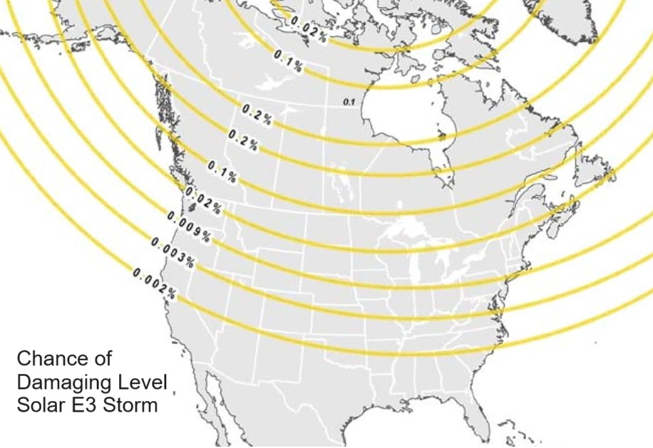

For E3 EMP intrusion via power lines, the most common (and effective) protection for amateur radio stations is isolation from mains power, i.e., using battery power instead of AC power, since the long AC power lines stretched across miles of territory are the biggest threat. There are several things to consider when planning your protection, however, whether using a DC or AC power source:

- AC - Are you using a common surge protection device to protect radios and/or power supplies? These usually protect well against sudden voltage spikes, but reset after a short time and may allow a long-duration E3 voltage event to get through to equipment.

- DC - How is your DC power supply charged? If your charger is an AC unit, is the charger protected? In an EMP event, the charger may be destroyed and protect any equipment downstream but this is not reliable, so you would need to protect or disconnect the charger from mains power before the EMP event.

- DC - Is your DC power source solar or wind/hydro power, or charged by these methods? While most Solar Photo-Voltaic (PV) panels and wind or hydro generators are considered fairly immune to EMP as an item, any long lines from them to your equipment (generally over 30 feet long) could be susceptible to some induced voltage (although nowhere near as high as the mains), so you may wish to protect any sensitive electronics such as solar controllers, generator regulators with appropriate (AC or DC) surge protection devices on the incoming line before the devices. Such devices can also provide protection from lightning strikes as well.

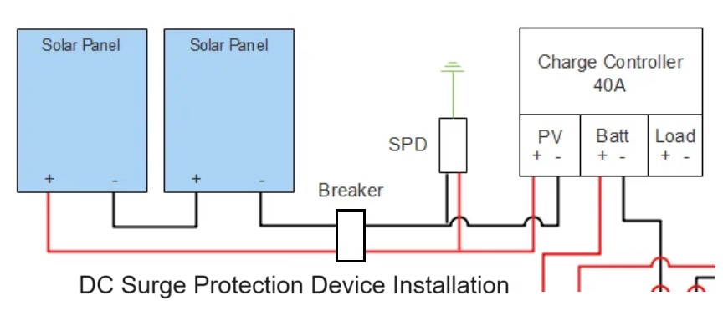
As for the other entry point for EMP damage - the antenna system - some things to evaluate are the length of your antenna and associated cabling, and items that may already be providing protection. For instance, a 70cm J-pole fed by 50 feet of Coaxial cable is not going to be very vulnerable to E3 EMP. Conversely, a full-wave 80m band loop fed by 100ft of coax may be induced to provide enough voltage to damage sensitive electronics. Is your system properly grounded and protected from lighting? If so, you may already have all the protection you would likely need from an E3 EMP event.

More detailed reading from government and research organizations:

https://www.researchgate.net/publication/283806320_Protecting_power_equipment_against_magnetohydrodynamic_effects_MHD_of_electromagnetic_pulses_EMP#pf2

https://www.energy.gov/sites/default/files/2023-08/CESER-Waveform-Application-Guide-2023-07_0.pdf

https://www.cisa.gov/sites/default/files/publications/19_0307_CISA_EMP-Protection-Resilience-Guidelines.pdf

https://www.resilientsocieties.org/uploads/5/4/0/0/54008795/protecting_us_electric_grid_communications_from_emp.pdf

