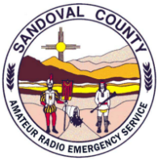 | NM SCARES Meeting Minutes:  October 19 , 2026 1900hrs | 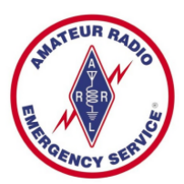

In Attendance:
Bill Mader – K8TE – ARRL Section Manager
John Betz II– KI5YIF – SCARES – V. President/Emergency Coordinator
Brian Britt – KG5WED – SCARES/CERT – Secretary/Webmaster
Mike Chirin – NM5MC – SCARES – Treasurer
Chris Drummond – NM5F – SCARES – Repeater Docent
Gary Surad – K5BIQ – SCARES/CERT – Board
Yul Bratcher – WA5YUL - SCARES/CERT
Dominic Tanner – KI5WTR - SCARES
Michael Smith – KI5NBP – SCARES
David Ham – N6SIK - SCARES
The Vice-President, John, KI5YIF, opened the meeting with leading the group in the Pledge of Allegiance. He then moved on to the short list of agenda items that he had. These were:
- Current/Upcoming Weather Conditions – predicted rainstorms and colder weather approaching, John advised all members to be aware of changing conditions and prepare accordingly, including using care when traveling
- Reminder for the SCARES presentation to HDARC, November 21stfrom 1130 – 13:30, asking for volunteers to assist.
- Great SHAKEOUT exercise - Brian, KG5WED participated in the drill, and gave a short critique on what went well, and what did not (primarily some conflicting directions coming from multiple sources).
- Call for upcoming meeting ideas – exercise planning, Go-box show and tell, training sessions during meetings (more P2P Winlink training was suggested, using Go-boxes for the November meeting)
A short discussion then ensued around various communications issues noted by members, including connectivity to adjoining counties nets. It was suggested all members test connection to other ARES nets nearby in case of a comm out situation.
The ARRL Section Manager, Bill, K8TE then briefed everyone on recent things he noted during the Duke City Marathon. One key takeaway was the failyre of many stations to properly identify with their callsigns in addition to Tactical Calls, and a lack of Radio Discipline by a few individuals where brevity was concerned. He also noted that if readability problems are noted during a net or event, it is important to let the station know of the issue, as they may be unaware.
Bill also advised everyone of a policy change on eBay concerning the sale of radio equipment, which now requires proof of FCC certication for some radios.
The meeting adjourned at 1950hrs.
