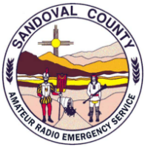 | NM SCARES Meeting Minutes:  September 21, 2026 1900hrs | 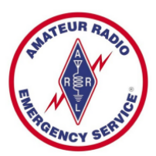

In Attendance:
Theo Shaffers – KI5IBZ - SCARES – President/District Emergency Coordinator
John Betz II– KI5YIF - SCARES – V. President/Emergency Coordinator
Brian Britt – KG5WED – SCARES/CERT – Secretary/Webmaster
Mike Chirin – NM5MC – SCARES – Treasurer
Chris Drummond – NM5F – SCARES – Repeater Docent
Gary Surad – K5BIQ – SCARES/CERT – Board
Tom Simmons – W5THS – SCARES/CERT
Marc Matheson – KD6KR - SCARES
Yul Bratcher – WA5YUL - SCARES/CERT
Jim Frazier - KC5RUO – BCARES/SCARES/AFMARS
Michael Smith – KI5NBP – SCARES
David Ham – N6SIK - SCARES
The President, Theo, KI5IBZ, opened the meeting with leading the group in the Pledge of Allegiance. He then briefed the members of a planned agenda list he had developed:
- First was a SITREP concerning local weather and hazards to be aware of, including the upcoming NOAA forecast for possible flooding conditions due to wetter than normal precip levels. He also supplied the group with the phone number for the Sandoval County Emergency Management office (505-867-7625) in case any incident specific shelter information was needed.
- He asked the group to ensure they had any needed preparations done for the coming storm, such as generators, go-kits, etc.
- Theo also supplied the group with instructions for signing up with the Everbridge alerting system. The Everbridge App is available on both the Apple and Google Playstore, as well as being able to sign up by texting SANDOVALNM to 888777.
The discussion then turned to our current situation with our Pajarito Repeater repairs (link radio system and repeater antenna). Chris, NM5F informed the group that he was able to contact 2 climbers, one who had injured his shoulder and was now out of commision, the other that informed him that he does not do dish antennas due to the weight involved. Due to the seasonal weather changesover the next couple of months, this likely puts any work on Pajarito on hold until next Spring at the earliest. There was also some talk concerning a possible leftover antenna from a previous packet setup at the site, that might get the repeater back on the air, if only in stand-alone status.
The Treasurer, Mike, NM5MC, apprised the group of the current financials, those being $5281.52 in checking, and $10,181 in Savings, including a recent donation from Intel Benevity.
Other agenda topics that were discussed were:
- The ARRL is planning a SET exercise, with the focal weekend being October 3rd and 4th.
- Albuquerque UNM School and UNMH hospital has asked to start conversations around a Ham Radio Emergency Plan. This sparked a short discussion about interoperability with all the hospitals, as well.
- The ARRL Jamboree on the Air (JOTA) is October 16-18, if SCARES would like to coordinate with the local Boy Scout groups for some outreach.
- There is a NM Amateur Radio Preparedness Net every Friday at 0900, hosted on the Megalink system.
- The Albuquerque International Balloon Fiesta would be coming to the area from October 3-11, and may cause disruptions in travel a dnpublic service comms.
The Vice-President, John – KI5YIF, mentioned that he had received the High Altitude kit for the generator from Tom, W5THS, and would be installing that shortly.
The Secretary, Brian – KG5WED, then briefed the group on a recent communication from Jay, W5WHN, the NM Section EC, describing an incident where the city of Anthony, NM suffered an insider cyber attack that disrupted local communication equipment. He and Jay had discussed that such incidents were on the rise, and ARES had no specific plan to assist with such an incident, although they could be called upon to assist with one. Jay suggested it would be good to plan a SET exercise for this.
The brief by KG5WED prompted Jim- KC5RUO to remind the group that there is a planned simplex communications test coming up between the Bernalillo County EOC and the State EOC in Santa Fe, to test for a reliable link in a comm-out situation such as what occurred in Anthony.
Talk then turned to the final agenda item for the night – members getting connected with Meshcore equipment. Assistance was givent to members who had brought in new units that needed setup or needed help with the phone apps, as well as answering any questions that came up. Jim, KC5RUO, suggested a written step-by-step procedure on setting up mesh units.
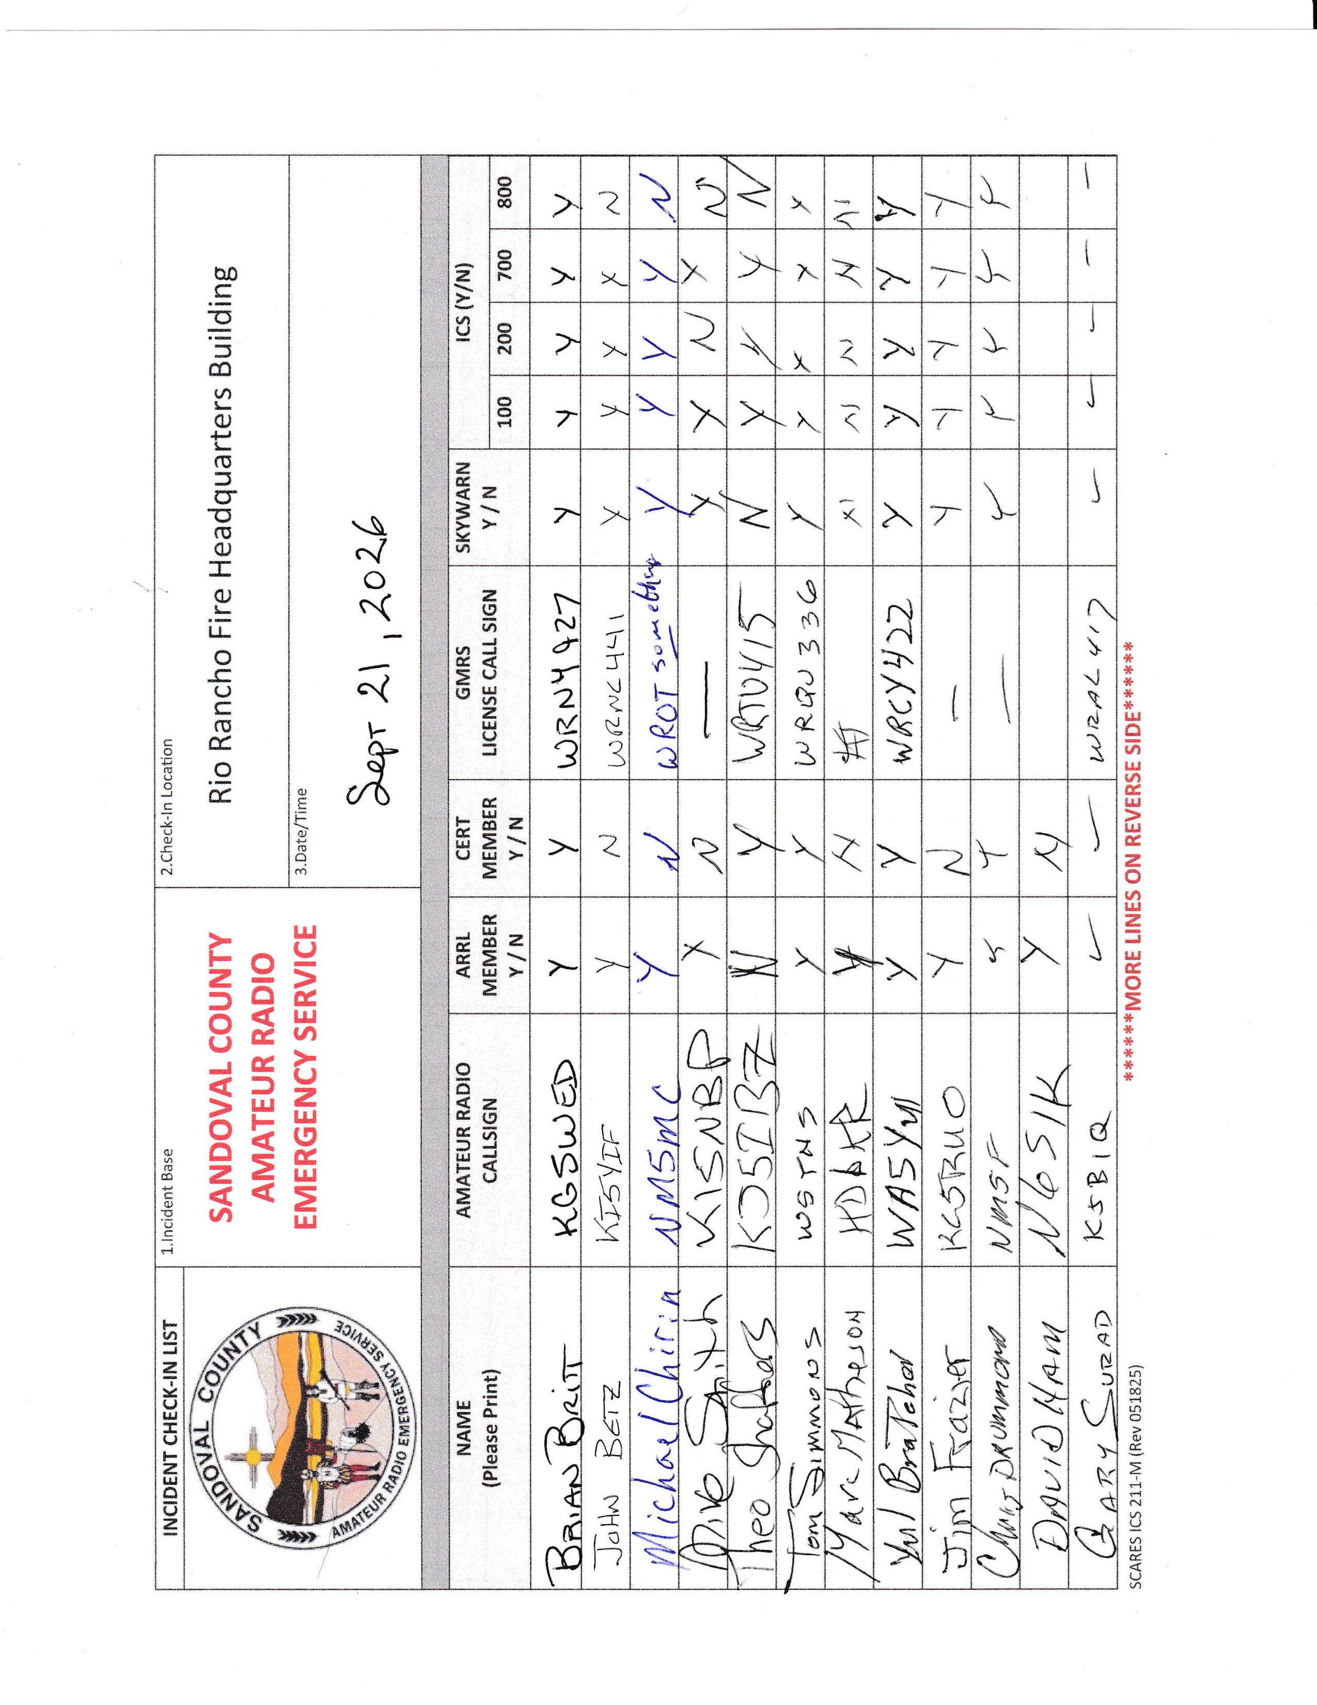
The meeting adjourned at 2005 hours.

